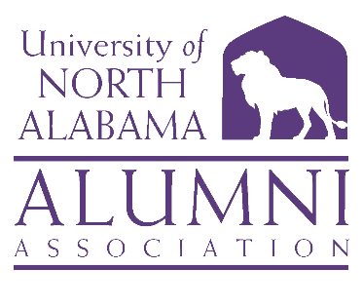

**UNIVERSITY OF NORTH ALABAMA**

**ALUMNI ASSOCIATION BOARD**

**October 11, 2024**

**10:00 a.m.**

**Marriott Conference Center**

**Singing River Room**

**AGENDA**

1. **Call to Order and Invocation** *Ms. Savannah Liles ’11, Chair*
2. **Roll Call and Quorum**  *Ms. Gaye Choat, ’81, Secretary*
3. **Approval of Past Minutes** *Ms. Savannah Liles*
4. **Approval of Agenda** *Ms. Savannah Liles*
5. **University and Advancement Update** *Ms. Barbie Terry, Associate Vice President*
6. **Alumni Relations Update** *Mr. Bishop Alexander,’09, Director, Alumni Relations*
7. **Committee Reports** 
   * **Executive Committee** *Ms. Savannah Liles*
   * **Nominations Committee** *Mr. Will Hodges, ’10, Chair*
     + **Members Rolling Off**
   * **Finance Committee** *Mr. Mike Byers, ’79, Chair*
     + **Budget Approval**
   * **Marketing and Communication** *Ms. Rita Harris, ’85, Chair*
   * **Development Committee** *Mr. John Haeger, ’99, Chair*
     + **Lions Under the Lights**
   * **Campus Engagement Committee** *Ms. Anna Milwee, ’14, Co-Chair*

*Dr. Lisa Clayton, ’00, Co-Chair*

1. **Old Business** *Ms. Savannah Liles*
   * **Vote on By-Laws and Constitution**
2. **New Business** *Ms. Savannah Liles*
3. **Adjourn**

**DATES TO REMEMBER**

**2025 BOT Meetings have not been announced yet, but our meeting dates will be announced ASAP**

**January 10: Founders’ Day and Board Retreat**

**January 23: Nashville Alumni, Friends and Family Mixer at Lipscomb Game**

**March 13: Light the Fountain**

**March 14: Lions Under the Lights**