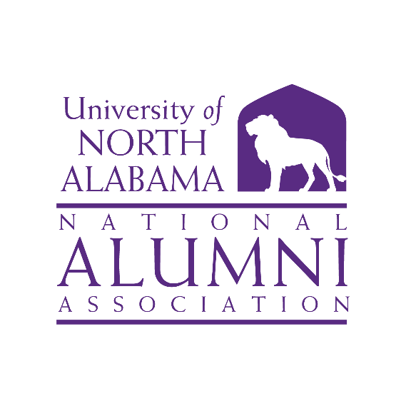

**Alumni Association Board 🞟 Coby Hall UNA**

**Thursday, March 21, 2024🞟 1:30 p.m. (CST)**

1. **Call to Order and Invocation** **Savannah Liles, Chair**

**Roll Call and Quorum Report** **Gaye Choat, Secretary**

Of the 34 Board members, 19 members were present.

* **Executive Committee Members Present:** Jeremy Baham, Rita Harris, Mike Byers, Gaye Choat, Lisa Clayton, John Haeger, Will Hodges, Savannah Liles, and Anna Milwee
* **Board-at-Large Members Present:** Melissa DeFoor, Allison Hall, Latasha Howell, Emily Kathryn McCann, Christa Raney, Holly Tate, and Denise Watts
* **Alumni Club Presidents Present:** Heather Beckwith, Jamie Ellis, Jeff Fletcher
* **Executive Committee Members Absent:**
* **Board-at-Large Members Absent:** Ryan Clayton, Mike Curtis, Ty Dennis, Ann-Marie Irons, Haley Newton, Tina Smith, and Henry White
* **Alumni Club Presidents Absent:** Lawrence Davis, Jr., Chris Lucas, Will Morgan, Laci Wideman, Zac Richardson, Kyser Samples, and Gale Satchel
* **Others Present:** Bishop Alexander *(Director of Alumni Relations)*, Barbie Terry, *(Assoc. VP for Alumni Relations and Annual Giving)*, and Vince Brewton *(Weldon and Delores Cole Honors College)*

Savannah Liles opened the meeting with prayer at 1:35 p.m. She introduced Vince Brewton who welcomed everyone to Coby Hall and gave a summary of the Honors College and the renovations being done to Coby Hall. The Honors College is estimating over 900 students for the fall semester.

1. **University and Advancement Update Barbie Terry**

Barbie opened her remarks by stating the University is trying to mimic the Alumni Association Board after the Board of Trustees and the Foundation Board. We will meet four (4) times a year. Attendance at meetings is important and everyone is encouraged to meet in-person for at least one (1) meeting per year and preferably that meeting being around Homecoming.

The Shine On, Gold Campaign is our $100 million campaign. We currently have $65 million. She encouraged everyone to communicate to alumni the importance of this campaign. The Music Performance Center is also on the campaign. The fundraising efforts for this are slow and more donors are needed. To learn more about the campaign go to [una.edu\ShineOnGold](http://www.una.edu\shineongold)

The Trustees approved Phase I of the stadium. Groundbreaking is scheduled for this summer.

Interviews are being conducted this week for Provost. Dr. Katie Kinney is the current Interim Provost.

1. **Alumni Relations Update Bishop Alexander**

Bishop mentioned dates for upcoming events:

* *Spring Commencement* is May 11-12, 2024. There are over 936 graduates walking. Gaye Choat is coordinating volunteers so contact her if you are interested in helping.
* *Homecoming* is referred to this year as *Alumni Weekend*. The dates are October 11-12, 2024.
* *UNA Handy Night* is July 23, 2024, from 6:00 p.m. to 8:00 p.m. Latasha Howell is heading up this event.
* The *Fraternity/Sorority Life 50th anniversary* will be celebrated April 19-20, 2024. The Greek Hall of Fame is being introduced for the first time this year.
* We are once again *Week Zero* for the beginning of the football season. We will be at the Cramton Bowl in Montgomery, Alabama on August 24, 2024. We are anticipating having a larger indoor venue this year.
* August 31, 2024, is the *UNA vs. Memphis* tailgate.
* September 7, 2024, is the *football home opener*.

Bishop thanked everyone for their service to the Board.

Bishop recently met with Jill Chambers *(Director of Admissions)* to discuss how alumni can help with recruitment. He showed a sign for “Welcome to the Lion’s Den” – Early College. Allison Hall asked if UNA has yard signs for incoming students to put in their yard saying things like “UNA Bound” or “Joining the Pride”. Bishop said he will check with Admissions.

Barbie stressed that when we are doing anything as a group to post it on social media so other alumni can see how active we are.

1. **Committee Reports**

* **Nomination Committee Will Hodges**

The period for accepting nominations for the Alumni Awards is March 1 to May 31, 2024. The due date for the committee to decide on the winners is June 10, 2024. To give the awards selection more transparency the committee is introducing the Alumni Board to vote on the winners.

Barbie Terry mentioned the application process has changed. People are now able to submit a nomination along with whatever information they may have on the individual. The Office of Alumni Relations will then contact the person to tell them they have been nominated and ask them to submit a resume’ or biography for the Nomination Committee. The Nomination Committee will review all nominations submitted before sending them to the Alumni Board for a vote. The inbox will be checked weekly and relayed instead of everything coming at one time. It was suggested the nominations be placed in the Nominations Committee folder on the Alumni webpage. Barbie also noted there is an AI program that is being introduced that removes the nominees name and other bias to make the voting fairer. Jeremy suggested those persons who were not selected be used in an Alumni Spotlight on social media. Their permission would be needed. The link for nominations is <https://www.una.edu/alumni/awards/index.html>

Will reported the committee put together objectives for the Board to utilize when recruiting new members.

* Make sure all colleges are represented.
* Make sure there are Board members in all geographic regions.
* Add younger alumni (ages 18-29 years).
* **Finance Committee Mike Byers**

As of February 1, 2024, there were$24,646.07 funds available. Ticket sales from Lions Under the Lights were $10,195.53. As of February 29, 2024, our balance was $34,741.60. As of this date, we have $38,766.60.

Mike presented the Operating Budget which is $12,640. Anna Milwee made a motion to accept the Operating Budget. Christa Raney seconded. The Operating Budget was approved.

* **Marketing and Communications Rita Harris**

The committee met on February 2, 2024, and approved their mission statement. The committee discussed at the next meeting the 1830 Giving Initiative and Jamie Ellis wrote a social media video script for the Board to use to promote the Alumni Association Takeover Day. Holly Tate developed a media schedule. Rita encouraged everyone to let her know what we can do to get more people involved.

The committee is looking at the various anniversaries around campus such as the Band is celebrating 75 years, Commercial Music celebrating 50 years to help promote these areas. Rita encouraged everyone to nominate at least one (1) person for the Alumni Awards. She thanked her committee.

* **Development John Haeger**

Barbie Terry gave the report in John’s absence.

Working Advantage is an alumni membership benefit. This program is being relaunched on April 1 through all avenues of communication. The annual fee is $25 for a single and $40 for a family. Once a person signs up for the program, they are given a code to log-in. This is a giving opportunity not a contribution. This program is for all alumni and friends.

We are renewing our partnership with Collette Travel. We presently have 3 trips planned. More information will be sent soon, and Barbie will reach out to Rita for her committee to help get the word out.

As of today, 26 of the 34 Board members have given to the 1830 Giving Initiative. To date we have 1,233 unique donors. The goal is 2,606. Unique donors are alumni and friends. John emphasized we need to focus 100% of Board members to give in March. We are now at 76%. Barbie mentioned we also need more alumni giving. We have a lot of friends giving but our alumni giving is low.

Jeremy Baham asked if Barbie could bring to Kevin Haslam *(VP for University Advancement)* the idea of having alumni serving on search committees.

* **Campus Engagement Lisa Clayton and Anna Milwee**

The committee handed out T-shirts at Light the Fountain. Lisa suggested a sign would be helpful to indicate who the T-shirts were for since a lot of students came to get a shirt. The student T-shirts were on another side of the plaza. Bishop said the shirts were for staff, faculty, and alumni. Barbie noted the Office of Advancement had paid for the shirts as a promotion for the Shine On, Gold campaign.

The committee will be helping with three events:

* Staff Senate
* Baseball tailgate on April 20, 2024
* Elite Speaker Series on April 23, 2024. Brenda Mays who played basketball at UNA is the speaker. The event will be in the Pierce Suite.

1. **Old Business Savannah Liles**

Barbie showed this year’s Challenge Coin. This coin is only given to those persons who donated in March.

Barbie detailed the Board expectations as they relate to attendance at events. It is recommended attendance at two (2) events a year. She encouraged people to plan an event in another area. She used the example of the ASUN Basketball Tournament at Lipscomb this year.

1. **New Business Savannah Liles**

The Alumni Association constitution needs to be changed to condense the document. The Executive Committee will serve as the Ad Hoc Committee to look at the constitution. Savannah will send it out to the committee. The goal is to have a revised constitution prepared for vote by October 1, 2025.

There is a Board Login on the Alumni webpage. The password was given out at the meeting. Each committee has a place for their committee minutes and reports. There is also a place for the agenda and minutes of all meetings. Members will be able to go to this area to access the agendas before each meeting instead of them being emailed.

1. **Adjournment**

The meeting was adjourned at 2:48 p.m.

Respectfully submitted,

Gaye Choat

Secretary