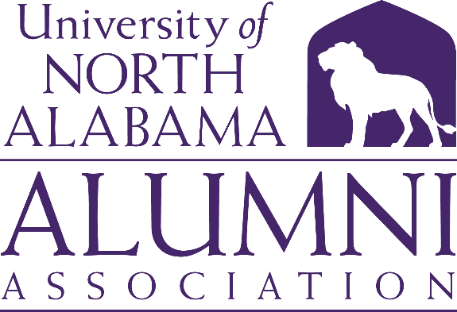

**Executive Committee 🞟 Marriott Conference Center**

**Friday, October 11, 2024 🞟 9:00 a.m. (CST)**

1. **Welcome** *Ms. Savannah Liles ’11, Chair*
   * Roll Call and Quorum Report: Gaye Choat, Secretary, noted a quorum has been met.
   * Executive Committee Members Present: Savannah Liles, Jeremy Baham, Mike Byers, Lisa Clayton, Gaye Choat, Rita Harris, Bishop Alexander, and Barbie Terry
   * Executive Committee Members Absent: John Haeger, Will Hodges, and Anna Milwee
   * Non-Executive Members Present: Emily Kathryn Gardner
2. **Review of Board Meeting Agenda** *Ms. Savannah Liles*

The meeting was called to order at 9:00 a.m. CST.

1. **Approval of Minutes** *Ms. Savannah Liles*

Rita Harris made a motion to approve the minutes. Lisa Clayton seconded the motion. The minutes were approved.

1. **Committee Reports/Action Items** *Ms. Savannah Liles*

* **Nominations Committee** *Mr. Will Hodges, ’10, Chair*

Barbie Terry spoke in Will’s absence. A formal report will be given at the Board meeting. Barbie explained how Affiliate Members will be selected. The Office of Advancement has named 2025 as the Year of Education. That year will be used to educate members of all University Boards on Time, Talent, and Treasure.

Members Rolling Off

Currently, we do not have any Executive Committee members rolling off.

* **Finance Committee** *Mr. Mike Byers, ’79, Chair*
  + Stadium

The Finance Committee met and approved a motion to fund a new Alumni Pavilion at Bank Independent Stadium. The amount is $110,000. $5,000 was paid last year and $5,000 will be paid this year. In the year 2025, we will begin paying $100,000. Mike suggested a fundraiser for at least 40 people contributing $250 over the next ten (10) years. Barbie mentioned a plaque would be placed in the stadium with all contributor’s names. Mike made a motion on behalf of the Finance Committee to raise the money for the Alumni Pavilion. Lisa Clayton seconded the motion. The motion was approved. It was also noted that the pledge the Alumni Association made to the Legacy Initiative will be paid off in February 2025.

* + Budget Approval

The budget of $12,890 as approved by the Finance Committee for the next fiscal year was presented. Mike made a motion to approve the budget. Jeremy Baham seconded the motion. The budget was approved.

* **Marketing & Communication** *Ms. Rita Harris, ’85, Chair*

The Committee this year has worked on publicity for Lions Under the Lights, Homecoming, and the 1830 Fund where Alumni Board members were encouraged to make a video telling alumni the benefits of giving. Holly Tate provided the Alumni Takeover plan for the 1830 Fund videos.

The Committee is currently working on “Flat Leo”. Alumni will be encouraged to take Flat Leo with them on their travels and take a picture to post on social media. Holly Tate and Michelle Eubanks are working on how to use the University Magazine to get Flat Leo to alumni. Lisa Clayton suggested we utilize Kilby students with this campaign.

The Committee will also be looking at ways to bring the history and traditions of UNA to alumni and students by showing former landmarks, UNA events, and traditions along with the history of LaGrange College.

Rita is asking alumni to approach alumni and students and ask them “What do you like/love about UNA?”. She asks that a short video be recorded on our phones and then sent to Bishop. These will be used periodically on the Alumni Association’s social media platforms.

* **Development Committee** *Mr. John Haeger, ’99, Chair*

Barbie reported in John’s absence.

* + Lions Under the Lights

The date is March 14, 2025. The committee will begin planning after Homecoming.

* **Campus Engagement Committee** *Ms. Anna Milwee, ’14, Co-Chair*

*Dr. Lisa Clayton, ’00, Co-Chair*

Lisa reported on the Faculty/Staff Engagement event on September 30, 2024. Approximately 40 people attended. The event was held at Singin’ River Brewery and Taco Mama catered. Lisa mentioned the possibility of establishing a Faculty/Staff Scholarship through the Alumni Association.

**V. Old Business** *Ms. Savannah Liles*

* Vote on By-Laws and Constitution

The Constitution and By-Laws were e-mailed to the Executive Committee by Gaye Choat for a vote. The Constitution and By-Laws were approved.

1. New Business *Ms. Savannah Liles*

There was no new business

1. Adjournment *Ms. Savannah Liles*

The meeting was adjourned at 9:50 a.m. CST

Respectfully submitted,

Gaye Choat

Secretary