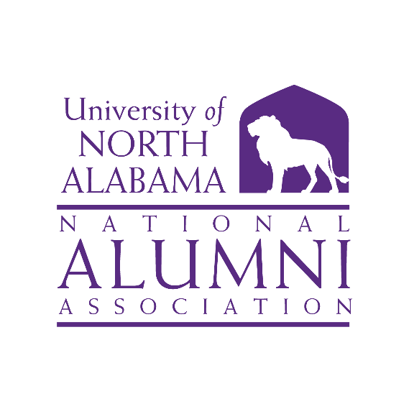

**Executive Committee Board 🞟 Raburn Wing, Room 110**

**Thursday, June 20, 2024 🞟 12:30 p.m. (CST)**

1. **Welcome** *Dr. Jeremy Baham, Vice Chair*

The meeting was called to order at 12:37 p.m.

1. **Review of Board Meeting Agenda** *Dr. Jeremy Baham, Vice Chair*

Lisa Clayton made a motion to approve the agenda, Gaye Choat   
seconded the motion. The agenda was approved.

1. **Approval of Minutes** *Dr. Jeremy Baham, Vice Chair*

Lisa Clayton made a motion to approve the minutes of the last meeting.  
John Haeger seconded the motion. The minutes were approved.

1. **Committee Reports/Action Items** *Ms. Savannah Liles*

**Nominations** *Will Hodges, Chair*

The committee has been working hard on the Homecoming Alumni   
Awards. They have been setting up files for each category and setting up a voting matrix. The full Alumni Board will be able to cast a vote this year for each category. A template will be sent out soon *(see attached Alumni Awards Nominee Template).* ***The due date for all votes to be cast and sent to Will Hodges is June 27, 2024***.

Will mentioned there are eleven (11) members who will roll off the Board. He noted that unlike Alumni Award winners who are only nominated prior   
to Homecoming, nominations for Board members can be accepted throughout the year. Please send in your nominations ASAP to Will for consideration for the Alumni Board.

**Finance**

*Barbie Terry gave the report in the absence of Mike Byers, Chair.* The  
three (3) funds the Alumni Association had has been combined into two   
(2) funds. The Benefits Fund has a balance of $1,476. This is our income from Working Advantage. The Greatest Needs fund has a balance   
of $20,726.99. The net change of $8,039.60 is from the expenses of Lions Under the Lights and two payments on our pledges for the stadium and the bench in Harrison Plaza. *(see attached).*

**Marketing & Communication**

Gaye Choat the report in Rita Harris’ absence. Our committee has   
completed the following tasks:

* + Helped publicize the Lions Under the Lights tickets sales.
  + We were highly active in the 1830 fundraising campaign and many of us posted our own videos and/or media announcements encouraging donations toward the campaign.
  + Holly Tate provided a media takeover plan for the Alumni office to use on the Alumni takeover day.
  + We encouraged nominations for alumni awards.

Our committee has discussed homecoming as well as important campus   
anniversaries and we look forward to generating creative ways to garner participation in these areas.

* + Bishop has agreed to make the necessary request through proper campus contacts to request a proclamation from Governor Kay Ivey recognizing the 75th anniversary of the UNA Band program for this fall.
  + Better communication for homecoming activities is being explored from our committee’s perspective.
  + We are exploring the idea of developing a historical film/video from an alumni perspective that could be used for informational purposes and/or recruiting purposes. We also have discussed including memorable landmarks of past students not only on campus but off campus (such as Chicago Deli, Court Street Café, Patrick’s Night Club, Biscuit Village, Southland, etc.)
  + Ideas were also discussed on how to include the important history of Lagrange College, especially for those going through SOAR. We agree that our students should understand where it all began.

Looking forward:

* January 11th- Founder’s Day – not only would our committee like to reach out to all of our alumni to post pics from across the nation, we would like to have a graphic developed of the mascot Leo for people to download, cutout, and take a pic in a location that best represents the town or region in which they live (example-San Antonio, the Alamo in the background.) This is following the same project many of your kids may have had to do called “Flat Stanley.” This would also be a wonderful time for the university media center to use information about the history of UNA, including the old Lagrange site.
  + Our committee will be welcoming alumni chapter presidents to our Zoom calls beginning in July!

We encourage each member of the board to post, text, email, call or speak to your friends about any fundraising campaign. We also encourage each member of the board to help make our upcoming homecoming the best yet as far as attendance and participation.

**Development** *Mr. John Haeger, Chair*

Packets to help solicit partnerships for Alumni Celebration at Homecoming will be sent to the Board. We are urging each Board member to ask at least one person or company to partner with UNA for this event. Barbie asked if we use the word partnership instead of sponsorship. Partnerships are tax deductible. There are different levels of partnership *(see attached HC Celebration Partner Letter)*. A link to purchase tickets for the Alumni Celebration will be coming soon. Tickets will be $25 this year. The question of how many tickets to comp will be addressed before the event. Alumni Award winners will have first option jn tickets along with probably past award winners. It was mentioned the award winners would only have two (2) seats comped to them. John suggested looking at other individuals such as the Greek Hall of Fame inductees for the current year. Booths will be in the lobby for those who purchased a partnership. Bishop announced that Balfour, the company that is creating the UNA legacy ring will be at the event as a partner. They will have the rings on display for ordering.

**Campus Engagement** *Dr. Lisa Clayton Co-Chair*

*Ms. Anna Milwee, Co-Chair*

A tailgate was set up for one of the baseball games. They partnered with the Staff Senate for an ice cream social. They would plan a faculty/staff event to get them more engaged. Savannah announced that Northwest Shoals Community College and UNA will be playing in a softball game at the end of October.

1. **Old Business** *Ms. Savannah Liles*

Barbie askedSavannah to put together an Ad Hoc Committee to review   
the constitution. The goal is to make it more concise and make it easier to read. The deadline for the committee to submit the revisions is September 1, 2024. At this point, Bishop and Barbie will review the revised constitution and submit it to the Board for their review. The Ad Hoc Committee will consist of: Savannah Liles, Gaye Choat, John Haeger, and Jeremy Baham. Barbie suggested as one of the revisions to add Vice Chairs to each committee.

1. **New Business** *Ms. Savannah Liles*

Barbie proposed that the Executive Committee stay on for one more year.   
 She and Bishop will talk to each member and see who is willing to stay the   
 extra year. John Haeger made the comment that he thought when the   
 restructuring was approved last October, the Executive Committee terms   
 started over.

1. **Adjournment** *Ms. Savannah Liles*

The meeting was adjourned at 1:35 p.m.

Respectfully submitted,

Gaye Choat

Secretary

Click on the link below to listen to the recording of the Executive Committee meeting.

**AA Executive Committee - June 20 - 12:30 pm**

[video1099194049 1.mp4](https://unaedu-my.sharepoint.com/:v:/g/personal/jmalexander_una_edu/EcwoF6B_So1GiPbgtIZrIEkBjeLSOY5R2M8kaneYdTV5GA?referrer=Outlook.Web&referrerScenario=email-linkwithembed)

**The next Alumni Association Executive Committee and Board meeting will be held Friday, October 11, 2024, at the Marriott Conference Center. The times of the meetings are to be determined but should be decided soon. At the meeting, members will be able to get a firsthand look at the setup and decorations for the Alumni Celebration.**

**UPCOMING EVENTS**

* **UNA Huntsville/Madison County Alumni Mixer**
  + Date: Thursday, June 27, 2024
  + Time: 6:00 p.m.
  + Location: MartinFed - 115 Clinton Ave E, Huntsville, AL 35801
  + RSVP Link: [www.tinyurl.com/cibhunts](http://www.tinyurl.com/cibhunts)
* **UNA Central Florida Alumni Mixer**
  + Date: Thursday, July 11, 2024
  + Time: 5:30 p.m.
  + Location: Historic Dubsdread Ballroom - Florida Room, 549 W. Par Street, Orlando, FL 32804
  + RSVP Link: [www.tinyurl.com/cibcentralfl](http://www.tinyurl.com/cibcentralfl)
* **UNA Decatur/Morgan County Alumni Mixer**
  + Date: Thursday, July 18, 2024
  + Time: 6:00 p.m.
  + Location: The Magnolia Room, 215 Moulton St. E., Decatur, AL 35601
  + RSVP Link: [www.tinyurl.com/cibdecatur](http://www.tinyurl.com/cibdecatur)
* **Week Zero Tickets - UNA Alumni & Friends Zone**
  + Date: Saturday, August 24, 2024
  + Time: Access to the suite will be available 3 hours before kickoff
  + Location: Multiplex - Cramton Bowl - Montgomery, Alabama
  + Ticket Price: $50 per person
  + Purchase Tickets: [www.tinyurl.com/weekzero24](http://www.tinyurl.com/weekzero24)

**PLEASE NOTE: If you are planning to attend any of these events, please RSVP at least 1-2 weeks prior to the event so we will be able to notify the caterer of the number of people expected to attend. Thank you.**