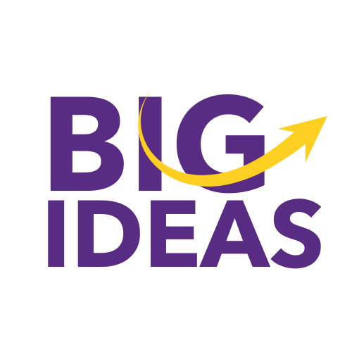

Master Schedule

|  |  |
| --- | --- |
| **Date** | **BIG Ideas Event** |
| Sun., Nov. 3, 2024 | Deadline for candidates to submit ideas through the QR code or the submission link |
| Mon., Nov.18 and Tues. Nov 19, 2024 | Candidates meet with a BIG Ideas panel to pitch their idea (virtually) |
| Sun., Jan. 5, 2025 | Deadline to submit Team information |
| Wed. Jan. 15, Thursday Jan. 16, 2025 | Kickoff, Workshop and Mentor Match (held at Generator 5pm - 8 pm) |
| Thurs., Jan. 30, 2025 | Deadline for Phase I Proposals/Videos |
| Mon, Feb 3 - Thurs., Feb. 6, 2025 | Phase I Evaluation |
| Fri., Feb 7, 2025 | Phase I Evaluation results are available to contestants |
| Tues., Feb. 4, 2025. 4-5:30 pm | Budgets and Timelines - Speaker series |
| Mon., Feb. 10 - Fri., March 19, 2025 | Contestants work with Mentors |
| Mon., Feb. 17, 2025 | Electronic Check-in I with BIG Ideas Team |
| Tues., Feb. 11, 2025; 4-5:30 pm | Presentation Skills - Speaker Series |
| Tues., Feb. 25, 2025; 4-5: 30 pm | Story Boarding- Speaker Series |
| Mon., March 10, 2025 | Electronic Check in II with BIG Ideas Team |
| Thurs. March 20, 2025 | Deadline for Phase II Proposals/Videos |
| Fri., March 21 - Friday April 4, 2025 | Judges are working on their feedback |
| Fri., April 4, 2025 | Deadline for Judges to submit feedback |
| Tues., April 8, 2025 | Awards Dinner/Celebration and check presentation |