

**for Employers**

**Registration & Job Posting Instructions**

**Part-time & Full-time * On- & Off-Campus * Internships & Co-Ops**

Thank you for your interest in hiring our UNA Pride.  The UNA Career Center uses LionJobs - a free, user-friendly job database that allows employers to recruit students.  Establishing your profile through LionJobs ensures that your job opportunities are visible to the largest student population.  Students and alumni have 24/7 access to the system to search for full-time, part-time, co-op and internship positions both on and off campus.

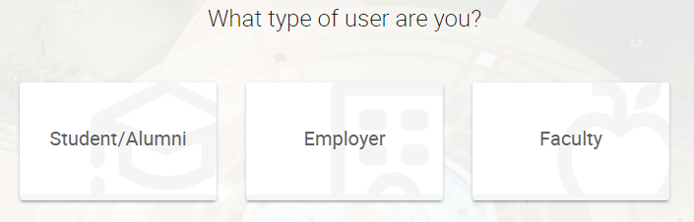

* Visit **http://career.una.edu/LionJobs**
* Click on “**Employer**”
* Click on "**SIGN UP AND POST JOB**" (The “Post a Multi-School Job” option incurs fees.)
* Complete the requested Company Information
* 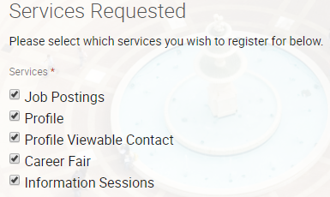Under Services Requested, leave all options checked (This allows use of all system features.)
* Complete the requested Contact Information Click the "**Next**" button
* You will receive a confirmation email within 24-48 hours asking you to set up a password. To protect our students, all employer registrations are reviewed and approved by Career Center Staff.



**Once you receive your confirmation email…**

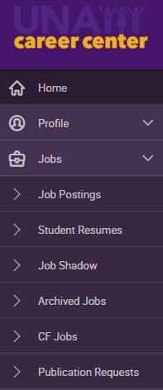

* 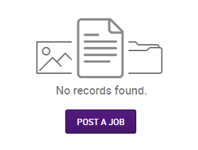After you set up your password, you will arrive at the homepage on LionJobs, click on Jobs, Job Postings, post a job
* Complete the required Position Information

***Please pay special attention*** to the “Resume Receipt” question

* If you select “e-mail,” any submitted resumes will be sent to the contact person via email
* If you select “Accumulate Online,” you will need to log-on to LionJobs to view the submitted resumes

Hold down the Control Key to select multiple options from a drop-down box.

* 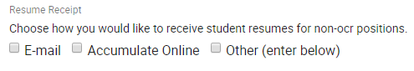If you select “Other,” a text box will appear entitled “How to Apply” and you can type specific instructions (i.e. mail/fax or deliver in person)
* Click the "**SUBMIT**" or “**SAVE AND FINISH LATER**” button



**Note**: Your account will be activated and your position posted within 1 business day upon approval from Career Center Staff during normal university hours. Process may be delayed if the university is closed. These positions are monitored regularly by Career Center staff. If you have any questions, please call the Career Center at 256-765-4276 or email [careercenter@una.edu](mailto:careercenter@una.edu).

