UNA Education Abroad
for Students with Disabilities
University of North Alabama

Education abroad is one of the greatest experiences available to you at the University of North Alabama. In addition to earning academic credits that apply to your degree program, education abroad offers excellent opportunities to expand your cultural and self- awareness; it is also linked to achieving higher GPAs and graduation rates. Additionally, it looks impressive on your resume. NEVER let your disability discourage you from pursuing an education abroad program!
UNA's Education Abroad staff can help you identify suitable programs.

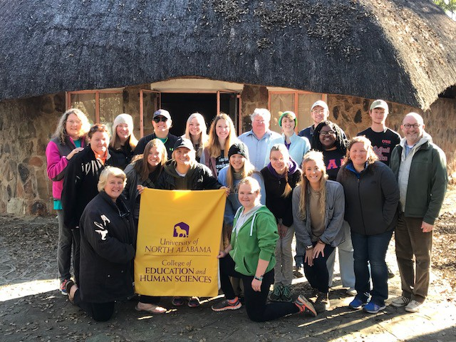
UNA students in Zimbabwe

Frequently Asked Questions

Why education abroad?

- Earn academic credit — All UNA education abroad programs offer course credit options.
- Cultural Awareness — Become more culturally competent by gaining an in-depth personal understand of other cultures from
What are my choices?

- UNA offers many types of education abroad programs, such as:
  - Faculty-led short-term
  - Magellan and Bilateral Exchange
  - Alternative Breaks
- UNA offers countless programs in more than 20 different countries, such as:
Can I afford it?

- Some programs cost nearly the same as studying for a semester at UNA, while others can actually be significantly cheaper.
- The Coordinator of Education
Abroad and the Director of Student Disability Services both work with

other parts of the world.
- Career Readiness and Resume bolster — set yourself apart from other applicants who lack an international experience.
- Networking — Make new friends and form lasting relationships with people from around the globe.
- Learn about yourself — Increase
- Germany
- Austria
- Chile
- Colombia
- Dominican Republic
- Japan
- Mexico
- The
Netherlands
- Serbia
- Wales
- Costa Rica
- Taiwan
- France
- Spain
- London
- Switzerland
- Zimbabwe
- South Korea
- Belgium
- Denmark
- Finland
students to find programs that they
believe would best fit a student physically, academically, socially, and financially.
- Most financial aid can be applied to
education abroad programs. It is always recommend that you talk to someone within Student Financial Aid to know for sure though.

your self-confidence and self- esteem by navigating life in a new environment.
- To search available programs, visit the Education Abroad website: https://www.una.edu/study-abroad/ index.html
- There are numerous scholarships opportunities available for Students with Disabilities (see page 3).

Getting Started and Planning
To find a program most suitable for you, it is important to keep in mind the following three keys to planning:
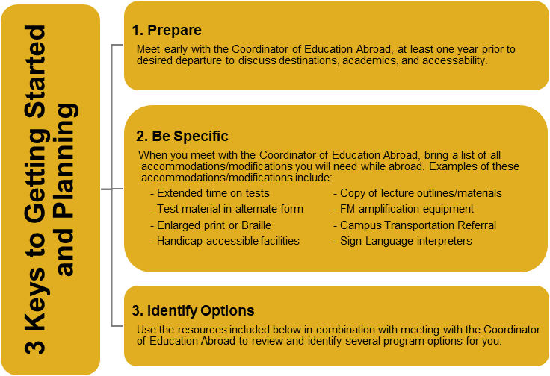

Resources
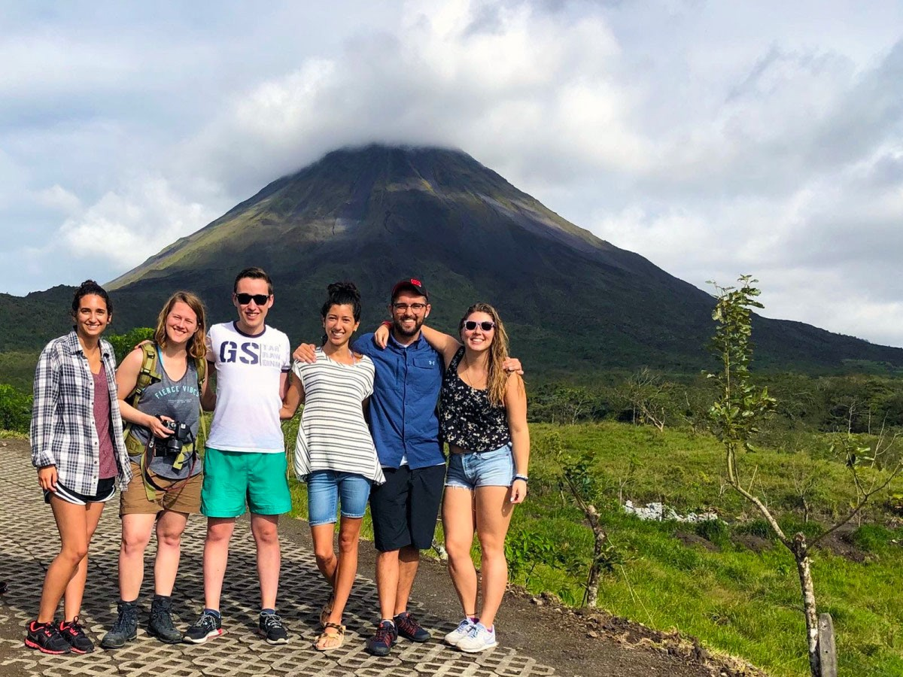
Visit the following websites to help identify study abroad program options and to find tips on preparing to study abroad.

UNA students in Costa Rica

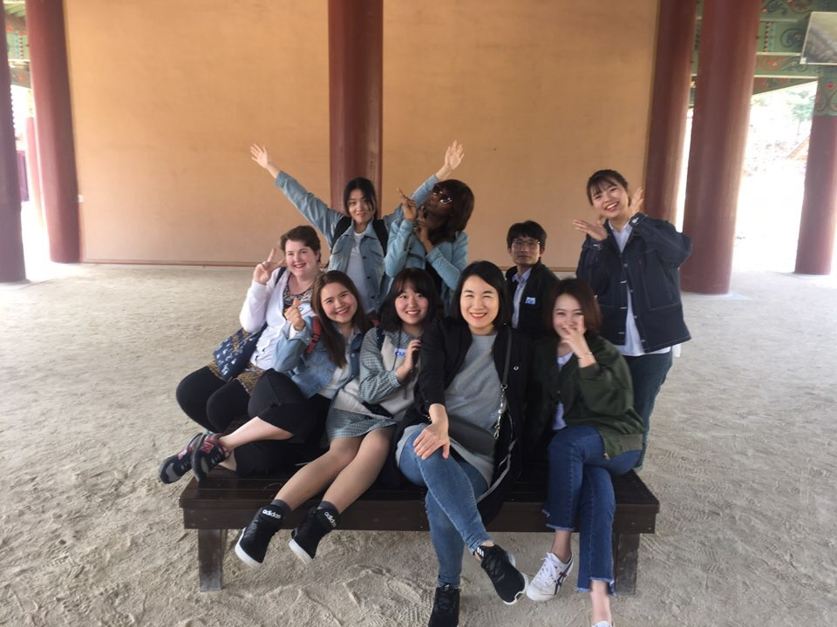
Students in Marlena, South Korea
Mobility International — Provides general information and how-to checklists for students with disabilities interested in studying abroad. http://www.miusa.org/

Abroad With Disabilities — Provides general information and how-to checklists for students with disabilities interested in studying abroad. http://www.abroadwithdisabilities.org/

Disability Rights and Education Defense — Outlines the legal measures taken by other countries to protect persons with disabilities http://dredf.org/legal- advocacy/international-disability-rights/
United Nations Enable — Provides public information on international topics related to disabilities. http://www.un.org/disabilities/

Zero Project — Offers an interactive map where you can search accessibility indicators as reported by disability services officials in particular countries.
http:///www.zeroproject.org

Access-Able Travel Source — Allows students to search “accessible” related infrastructure by country. http://www.access- able.com/dBase/index.cfm

Scholarship Opportunities for Students with Disabilities

- 180 Medical Scholarship Program: for students with spinal cord injury, spina bifida, transverse myelitis, or neurogenic bladder

- 1800 wheelchair Scholarship: students who apply must explore mobility issues on campus and/or express personal experiences with such issues

- American Council for the Blind: for students with vision loss

- Christine H Eide Memorial Scholarship: for students who are legally blind

CIEE Study Abroad/Mobility International:

- Council of Citizens with Low Vision International: offers several scholarships for students with low vision and those attending a school with programs for blindness and low vision studies
- Eric Marder Scholarship Program of IDF: for students living with primary immunodeficiency diseases

- Family Epilepsy Scholarship Program: for students living with epilepsy or family/caregivers of a person with epilepsy

- Geoff Brachvogel Memorial Scholarship: for students with RSD, CRPS, or chronic pain

- Incight Education: for any student with a disability

- Lilly Reintegration Scholarship: for students with bipolar disorder, schizophrenia, schizoaffective disorder, and major depressive disorder

- Michael Yasick ADHD Scholarship: for students with ADHD

- Novotni Scholarship: for students with ADHD

Patient Advocate Foundation: scholarships for students who have been diagnosed with and/or actively treated for a life threatening illness within the last 5 years

- Proyecto Visión: a bilingual website for youth with disabilities

- Scholarship Trust for the Hearing Impaired: scholarships for areas of need (within education) directly related to hearing loss

- Shire ADHD Scholarship Program: for students diagnosed with ADHD

- The Organization for Autism Research: scholarship for students with Autism

- Ulman Cancer Fund for Young Adults: scholarships for young adults who have or have had cancer, or have cared for a family member with cancer


UNA Students in Guatemala

Meet with Us!
Start your journey today with Education Abroad at UNA!!

Walk-ins are always welcome, but appointments are encouraged you can schedule your appointment at;
https://www.una.edu/study-abroad/index.html
Office Location: 133 Powers Hall Office Phone: 256.765.5217 Office Email: kniehaus@una.edu Semester office hours:
Monday through Friday 8:00am – 12:00pm and 1:00pm – 4:30pm.

Summer office hours:
Monday through Thursday 7:30am – 12:00pm and 1:00pm – 5:00pm, and 8:00am – 11:30am Friday.

UNA Students in Würzburg, Germany

UNA Student Testimonials

"Education Abroad allowed me to see the world in a different view.
I was able to step out of my comfort zone and grow in confidence and love for different cultures. I highly recommend this experience for students wishing to see more."
-Hannah Spradlin
Participatant in the Magellan Exchange Program to Rennes, France for the Spring 2018 semester.

