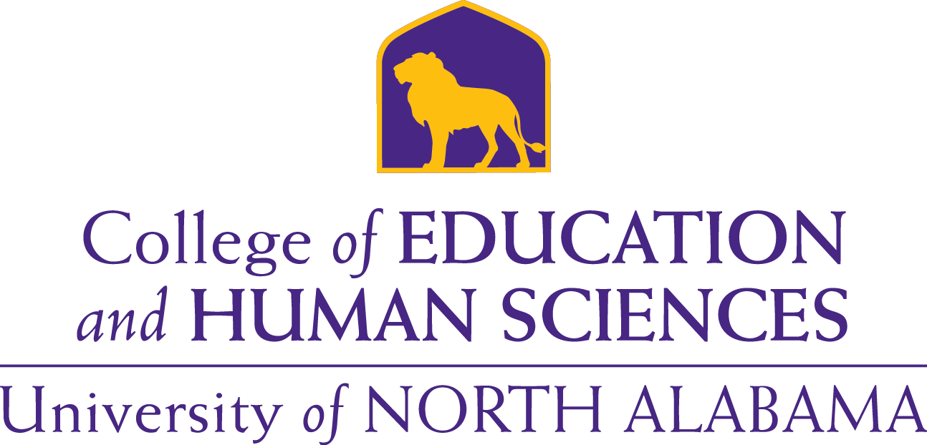

**COEHS Recruitment Plan**

2017

**TABLE OF CONTENTS**

1. Mission 3

1. Recruitment Priorities 4
2. Objectives & Recruitment Strategies 4

1. Action Steps 5

1. Summary 8

**MISSION**

The Conceptual Framework represents a shared vision for preparing educators to work effectively in P–12 schools and provides direction for programs, courses, teaching, candidate performance, scholarship, service and accountability in the context of a global community. The Conceptual Framework aligns with the University of North Alabama’s institutional mission of *“engaging in teaching, research, and service in order to provide educational opportunities for students, and environment for discovery and creative accomplishment, and a variety of outreach activities meeting the professional, civic, social, cultural, and economic development needs of our region in the context of a global community.”*

The Conceptual Framework reflects current research-based knowledge and effective practices through professionalism, assessment, collaboration, technology, diversity and reflection. The UNA College of Education and Human Sciences prepares ***Knowledgeable Practicing Professionals*** who:

1. Have content and pedagogical knowledge and abilities demonstrating professionalism through a set of beliefs, actions, dispositions and ethical standards that form the core of their practice;
2. Have the knowledge and ability to evaluate student performance use assessment strategies to guide teaching and learning, especially impact on student learning, and to strengthen instruction and increase professional growth;
3. Form communities of learners with other teachers, parents, and members of the community, through collaboration, teamwork, and research-based approaches;
4. Use technology to support assessment, planning and instruction for promoting student learning;
5. Value and plan for diversity in curriculum development, instructional strategies and in the promotion of social consciousness and global perspectives of teaching and learning;
6. Know and use self-awareness and reflection as decision-making tools for assuring student learning, professional performance and personal growth.

Graduates of the University of North Alabama’s College of Education and Human Sciences are knowledgeable practicing professionals who are prepared for the opportunities and challenges of the P-12 environment with a commitment to helping students achieve and excel in the classroom and beyond.

**RECRUITMENT PRIORITIES**

**Purpose:** The College of Education and Human Sciences (COEHS) strives to recruit diverse and academically talented students while maintaining admission standards for entering new first-time freshmen, new transfers, and graduate students. The long-term goals are as follows:

**Long-Term Goals**

* To recruit a larger applicant pool of academically talented candidates for all teacher education programs that have high academic achievement and ability
* To recruit high-quality candidates from diverse populations
* To market and recruit candidates to staff shortage and hard-to-staff areas such as STEM, ELL, and students with disabilities/special education
* To market and recruit nonteaching bachelor degree majors who are interested in pursuing k-12 teaching licenses
* Market the strength of teacher education
* Increase graduate recruitment for LEAD Initiatives

**Recruitment Focus**

**Undergraduate**

* Freshmen
* Undeclared
* Transfer

**Graduates**

* LEAD Initiative
* Alternative Class A

**OBJECTIVES & RECRUITMENT STRATEGIES**

1. Recruit a larger applicant pool of candidates for all teacher education programs
2. Recruit high-quality candidates from diverse populations
3. Recruit candidates to hard -to-staff areas such as STEM, ELL, and students with disabilities
4. Recruit candidates that have high academic achievement and ability

**ACTION STEPS**

**Strategies for Freshmen**

* Recruitment opportunities (1,2,3,4)
  + My UNA Day & College follow-up
  + UNA Fall and Spring Preview Day
  + SOAR: Assist with advising and class schedule
  + Career fair: UNA and local schools
  + Contact counselors and invite students for Shadow Day at UNA
* Contact area high schools that have Future Teacher Organizations and send a representative from the College of Education and Human Sciences to attend a meeting to discuss teacher education programs at UNA. Include high schools that have high diverse populations. Emphasize teaching opportunities in programs such as collaborative special education, math, science, technology, and English language learners. (1,2,3)
* Invite Future Teacher Organizations to visit UNA and schedule campus tours to include visits to classrooms. (1)
* Phone and email campaign (1)
* Contact area high schools counselors and share information about teacher education programs and available scholarships at UNA. Emphasize teaching opportunities in programs such as collaborative special education, math, science, technology, and English language learners. (1,3)
* Obtain a list of freshmen who are declared education majors who have a minimum 2.75 GPA and send them a letter from the College of Education and Human Sciences containing information about the teacher education programs offered in the COEHS. (1,2,4)
* Obtain a list of students who have been awarded an Excellence Scholarship (Vanguard, Academic, Valedictorian/Salutatorian, Leadership, and Presidential Mentors Academy) and send them a letter from the College of Education containing information about the teacher education programs offered in the COEHS. The Excellence Scholarships are scholarships awarded to students who demonstrate high academic achievement and ability. The Presidential Mentors Academy scholarships are awarded to students whose racial group is underrepresented at the University. (1,4)
* Invite the students to an open house, student organization meetings, and other functions in the COEHS.
* Send follow-up emails to students at mid-term and end of semester to ensure that they are still planning on pursuing a major in education. (1,2,3,4)
* Attend career and college fairs with personnel from UNA’s Admission Recruiters. (1,2,3,4)
* Recruiting Strategies with Native American students. (1,2)-These students are welcomed on campus with a tour of all facilities and then taken to the Native American Memorial Wall located off campus. Currently Limestone County and Madison County Schools are participating.
* The College of Education and Human Sciences Student Ambassadors serve as official host and hostess representatives, student recruitment agents, mentors, and student advisors to the Dean. They will assist with student recruitment, speak to community and university groups, and represent the College at receptions and meetings. (1,2)

**Strategies for Undeclared Majors**

* Obtain a list of undeclared majors who have a minimum 2.75 GPA and send them a letter from the College of Education and Human Sciences containing information about the teacher education programs offered in the COEHS. Emphasize teaching opportunities in programs such as collaborative special education, math, science, technology, and English language learners. (1,2,3,4)
* Invite the students to an open house, student organization meetings, and other functions in the COEHS. (1,2,3,4)
* Send follow-up emails to students at mid-term and end of semester to gauge interest in pursuing a teacher education program of study. (1,2,3,4)

**Strategies for Transfer and Nontraditional Students**

* Recruitment opportunities (1,2,3,4)
  + Develop early acceptance program
  + Develop dual enrollment program
  + Collaborate with 2-year colleges and increase an on-campus presence in those campuses.
  + Shadow Days - Invite students to visit campus and attend classes.
  + Send follow-up emails to students at the end of the semester
  + Send a COEHS representative to community college career fairs.
* Contact area community college admission offices to obtain lists of students who are planning on pursuing a teacher education program and arrange a time for an articulation meeting with those students. Emphasize teaching opportunities in programs such as collaborative special education, math, science, technology, and English language learners. (1, 3)
* Invite the students to an open house, student organization meetings, and other functions in the COEHS. (1,2,3,4)
* Share information concerning teacher education admission requirements with education advisors at the area community colleges. (1,4)
* Have a COEHS representative attend college and career fairs at community colleges. (1,2,3,4)
* Obtain a list of students who have been awarded a Phi Theta Kappa Scholarship and send them a letter from the College of Education and Human Sciences containing information about the teacher education programs offered in the COEHS. Phi Theta Kappa Scholarships are awarded to transfer students who have a minimum 3.25 transferable GPA. Emphasize teaching opportunities in programs such as collaborative special education, math, science, technology, and English language learners. (1, 3,4)

**Strategies for Graduate Students**

* Recruit individuals who have completed a non-teacher certification degree program from a regionally accredited institution who meet the admission requirements for the Alternative Class A program. (1,2)
* Attend district wide beginning of the year in-service meetings to promote the COEHS graduate programs. (1,2)
* Send a COEHS representative to Graduate School Expositions. (1,2)
* Share information about advanced degree programs with all program completers at the final internship meeting. (1, 2, 3, 4)
* Contact area school district offices and obtain names of teachers who have not completed advanced degrees and send those teachers a letter from the College of Education containing information about the advanced programs offered in the COEHS. (1, 2, 3, 4)
* Attend P-12 faculty meetings to discuss our programs and encourage enrollment. (1,2,3,4)
* Attend the district wide beginning of the year in-service meeting and set up a table with COEHS information regarding advanced programs. Have interested teachers provide contact information so that a COEHS faculty can contact them regarding admission and program information. (1, 2, 3, 4)
* Send advanced program information to mentor/ cooperating teachers. (1, 2, 3, 4)
* Continue and expand the Local Educator Advanced Degree (LEAD) Initiative. (1, 2, 3, 4)
* Have a COEHS representative attend on campus Graduate School Expositions. (1, 2, 3, 4)
* Obtain a list of students from UNA’s Registrar’s office who have completed non- teacher certification degrees in areas in which Alternative Class A programs are offered and who meet the requirements for admission to Alternative Class A programs. (1,2,4)
* Send qualified students information regarding admission and program requirements for Alternative Class A programs. (1,2,4)

**SUMMARY**

The College of Education and Human Sciences recruitment plan outlines strategies to achieve or exceed our enrollment goals. The development of this recruitment plan serves as a baseline. The recruitment plan also ensures the recruitment of academically qualified and talented students that meet or exceed CAEP accreditation standards.