

University of North Alabama
Educator Preparation Program
Advanced Program Employer Survey
Distributed Spring 2021 to Fall 2020 Graduates of Advanced Programs
Report with 50% response rate
Q2 - Which grade level(s) did your recent UNA graduate teach last year? Check all that apply.
# | Answer | %
1 | PK | 0.00%
2 | K | 14.29%
3 | 1 | 0.00%
4 | 2 | 0.00%
5 | 3 | 0.00%
6 | 4 | 4.76%
7 | 5 | 4.76%
8 | 6 | 9.52%
9 | 7 | 19.05%
10 | 8 | 19.05%
11 | 9 | 14.29%
12 | 10 | 4.76%
13 | 11 | 4.76%
14 | 12 | 4.76%
15 | Building Administrator/Teacher Leader | 0.00%
16 | Central Office Administrator | 0.00%
 | Total | 100%

Q3 - Which subject areas do your recent UNA graduate teach? Check all that apply.
# | Answer | %
1 | Early Childhood Education | 20.00%
2 | Elementary Education | 40.00%
3 | Collaborative Special Education K-6 | 10.00%
4 | English Language Arts | 0.00%
5 | Biology | 0.00%
6 | Math | 10.00%
7 | Business Marketing | 0.00%
8 | Chemistry | 0.00%
9 | French | 0.00%
10 | General Science | 0.00%
11 | General Social Science/Studies | 0.00%
12 | Geography | 0.00%
13 | German | 0.00%
14 | History | 0.00%
15 | Music-Choral | 0.00%
16 | Music-Instrumental | 0.00%
17 | Physical Education | 0.00%
18 | Physics | 0.00%
19 | Spanish | 0.00%
20 | Visual Arts | 0.00%
21 | Collaborative 6-12 | 20.00%
22 | Building Administrator/Teacher Leader | 0.00%
24 | Central Office Administrator | 0.00%
 | Total | 100%

Q4 - Was this graduate certified to teach that subject area(s)/grade level? Or, is this graduate certified for his or her administrative position?

# | Field | Minimum | Maximum | Mean | Std Deviation | Variance
1 | Was this graduate certified to teach that subject area(s)/grade level? Or, is this graduate certified for his or her administrative position? | 1.00 | 2.00 | 1.11 | 0.31 | 0.10

# | Answer | %
1 | Yes | 88.89%
2 | No | 11.11%
 | Total | 100%

Q5 - In which school system was this graduate employed?
# | Answer | %
1 | Colbert County | 0.00%
2 | Decatur City | 0.00%
3 | Florence City | 0.00%
4 | Franklin County | 11.11%
5 | Lauderdale County | 33.33%
6 | Lawrence County | 0.00%
7 | Muscle Shoals City | 0.00%
8 | Russellville City | 0.00%
9 | Sheffield City | 0.00%
10 | Tuscumbia City | 0.00%
11 | Other | 55.56%
 | Total | 100%

Q6 - UNA's Advanced Teacher Education Program has prepared this student to:
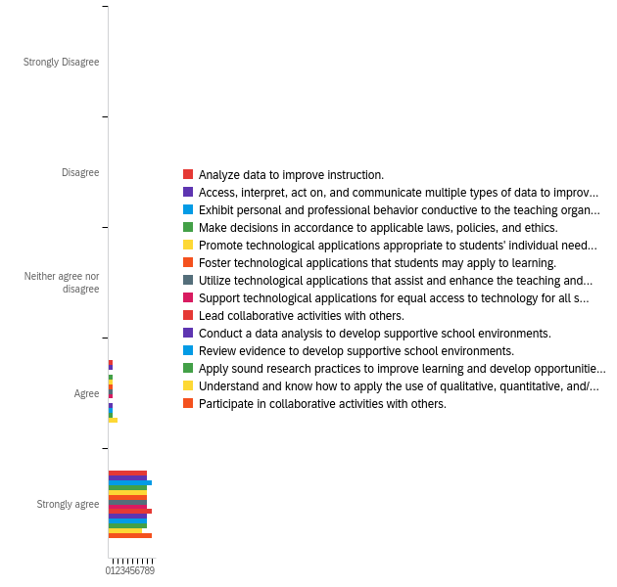

# | Field | Minimum | Maximum | Mean | Std Deviation | Variance
1 | Analyze data to improve instruction. | 4.00 | 5.00 | 4.89 | 0.31 | 0.10
2 | Access, interpret, act on, and communicate multiple types of data to improve outcomes for students. | 4.00 | 5.00 | 4.89 | 0.31 | 0.10
3 | Exhibit personal and professional behavior conductive to the teaching organization. | 5.00 | 5.00 | 5.00 | 0.00 | 0.00
4 | Make decisions in accordance to applicable laws, policies, and ethics. | 4.00 | 5.00 | 4.89 | 0.31 | 0.10
5 | Promote technological applications appropriate to students' individual needs. | 4.00 | 5.00 | 4.89 | 0.31 | 0.10
6 | Foster technological applications that students may apply to learning. | 4.00 | 5.00 | 4.89 | 0.31 | 0.10
7 | Utilize technological applications that assist and enhance the teaching and learning process. | 4.00 | 5.00 | 4.89 | 0.31 | 0.10
8 | Support technological applications for equal access to technology for all students. | 4.00 | 5.00 | 4.89 | 0.31 | 0.10
9 | Lead collaborative activities with others. | 5.00 | 5.00 | 5.00 | 0.00 | 0.00
10 | Conduct a data analysis to develop supportive school environments. | 4.00 | 5.00 | 4.89 | 0.31 | 0.10
11 | Review evidence to develop supportive school environments. | 4.00 | 5.00 | 4.89 | 0.31 | 0.10
12 | Apply sound research practices to improve learning and develop opportunities for all students. | 4.00 | 5.00 | 4.89 | 0.31 | 0.10
13 | Understand and know how to apply the use of qualitative, quantitative, and/or mixed methods research methodologies. | 4.00 | 5.00 | 4.78 | 0.42 | 0.17
14 | Participate in collaborative activities with others. | 5.00 | 5.00 | 5.00 | 0.00 | 0.00

# | Question | Strongly Disagree |  | Disagree |  | Neither agree nor disagree |  | Agree |  | Strongly agree
1 | Analyze data to improve instruction. | 0.00% | 0 | 0.00% | 0 | 0.00% | 0 | 11.11% | 1 | 88.89% | 8
2 | Access, interpret, act on, and communicate multiple types of data to improve outcomes for students. | 0.00% | 0 | 0.00% | 0 | 0.00% | 0 | 11.11% | 1 | 88.89% | 8
3 | Exhibit personal and professional behavior conductive to the teaching organization. | 0.00% | 0 | 0.00% | 0 | 0.00% | 0 | 0.00% | 0 | 100.00% | 9
4 | Make decisions in accordance to applicable laws, policies, and ethics. | 0.00% | 0 | 0.00% | 0 | 0.00% | 0 | 11.11% | 1 | 88.89% | 8
5 | Promote technological applications appropriate to students' individual needs. | 0.00% | 0 | 0.00% | 0 | 0.00% | 0 | 11.11% | 1 | 88.89% | 8
6 | Foster technological applications that students may apply to learning. | 0.00% | 0 | 0.00% | 0 | 0.00% | 0 | 11.11% | 1 | 88.89% | 8
7 | Utilize technological applications that assist and enhance the teaching and learning process. | 0.00% | 0 | 0.00% | 0 | 0.00% | 0 | 11.11% | 1 | 88.89% | 8
8 | Support technological applications for equal access to technology for all students. | 0.00% | 0 | 0.00% | 0 | 0.00% | 0 | 11.11% | 1 | 88.89% | 8
9 | Lead collaborative activities with others. | 0.00% | 0 | 0.00% | 0 | 0.00% | 0 | 0.00% | 0 | 100.00% | 9
10 | Conduct a data analysis to develop supportive school environments. | 0.00% | 0 | 0.00% | 0 | 0.00% | 0 | 11.11% | 1 | 88.89% | 8
11 | Review evidence to develop supportive school environments. | 0.00% | 0 | 0.00% | 0 | 0.00% | 0 | 11.11% | 1 | 88.89% | 8
12 | Apply sound research practices to improve learning and develop opportunities for all students. | 0.00% | 0 | 0.00% | 0 | 0.00% | 0 | 11.11% | 1 | 88.89% | 8
13 | Understand and know how to apply the use of qualitative, quantitative, and/or mixed methods research methodologies. | 0.00% | 0 | 0.00% | 0 | 0.00% | 0 | 22.22% | 2 | 77.78% | 7
14 | Participate in collaborative activities with others. | 0.00% | 0 | 0.00% | 0 | 0.00% | 0 | 0.00% | 0 | 100.00% | 9

Q7 - What are your employment needs for faculty and/or administration (i.e., special education, ELA, STEM, math, ELL, early childhood, science, etc.)?

What are your employment needs for faculty and/or administration (i.e., special education, ELA, STEM, math, ELL, early childhood, science, etc.)?
None at this time
Special education, grades 1-4
Secondary SpEd, Math, Science, Business/Tech Ed
We are in need of a full-time curriculum coach.
STEM, SPED

Q8 - Do you have any additional information you would like to share with us regarding our Educator Preparation Programs?

Do you have any additional information you would like to share with us regarding our Educator Preparation Programs?
This candidate is an exceptional teacher one of the best we have.
Thanks for all you do. I am a proud UNA graduate! Roar Lions!
I have been very pleased with the employees that have received jobs within my system that are graduates from UNA.

