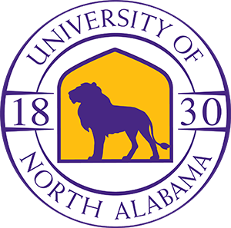

North Alabama Medical Center is always striving to enhance our clinical staff, in order to provide the best quality care to our patient’s every day.  We’ve engaged in another initiative that will help our employees excel.  NAMC has partnered with the University of North Alabama to offer a scholarship to NAMC employees who are accepted into specified online programs:

* RN to BSN nursing track
* RN to MSN nursing track
* Bachelor of Applied Health Science
* B.S/B.A in Interdisciplinary Studies
* M.Pr.S. in Professional Studies
* Bachelor’s in Business Administration

A scholarship of 20% of tuition and fees value of online courses will be extended to full-time NAMC employees who are enrolled in the outlined higher education classes.

Employees interested in this opportunity should contact the Admissions office at the University of North Alabama.

\*Once accepted to UNA, employees must have their Human Resources Department contact the UNA Business Office to confirm employment before the 20% tuition discount will be applied\*