Student CAPP

Degree Evaluation

Manual

Table of Contents

View a Previous Degree Evaluation 2

Generate a New Evaluation 4

Generate a What-If Analysis 7

How to Interpret a Degree Evaluation 11

Program Evaluation 11
General Requirements 13
Detail Requirements 15
Additional Information 17

View a Previous

Degree Evaluation

1. Log in to https://unaportal.una.edu
2. Click on Self-Service Banner.
3. Select the Student Tab.
4. Select the Student Records link.
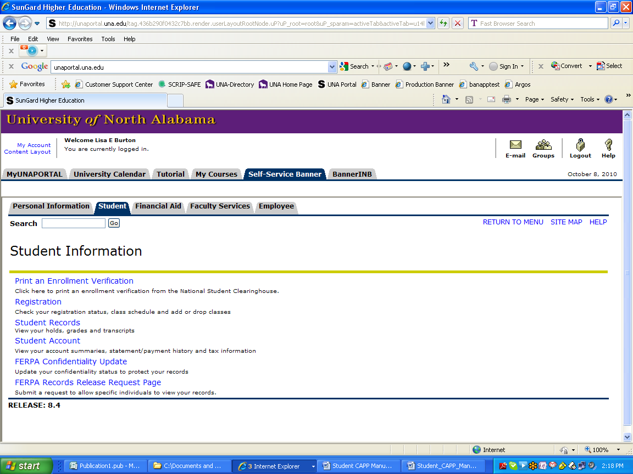

5. Click the link for CAPP Degree Evaluation.
6. Select the current term from the drop down menu.

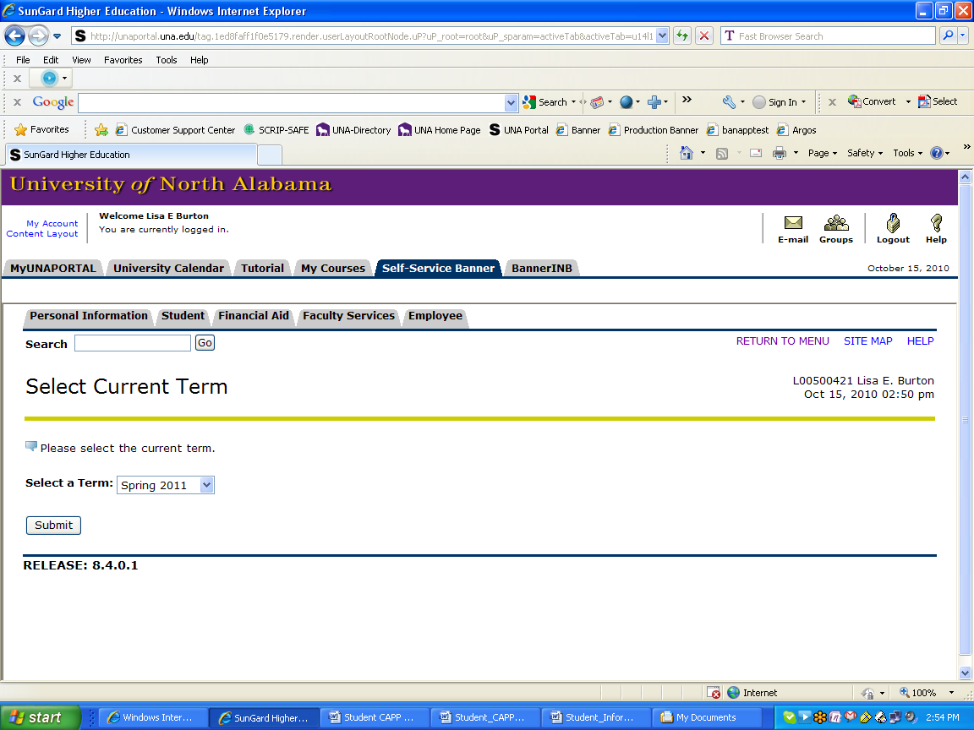

7. Click Submit.
8. Click View Previous Evaluations at the bottom of the page.

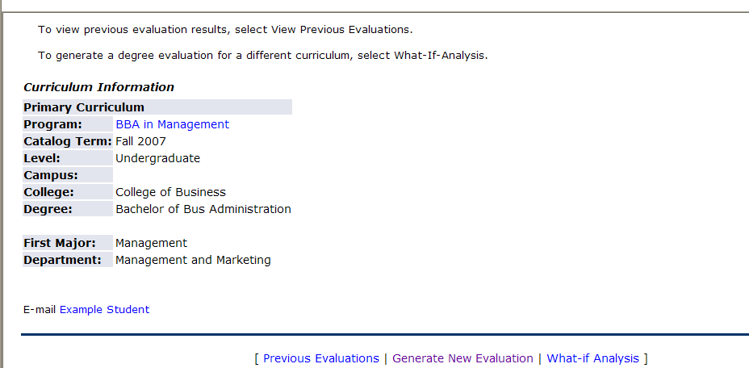

9. Select the evaluation you would like to view by clicking the program link.
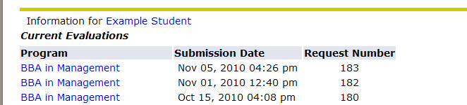

10. Select a CAPP Degree Evaluation display option in order to view the Degree Evaluation.
The options are General Requirements, Detail Requirements or Additional Information.

Note: It is recommended that the Detail Requirements display option is selected.
This will display the degree requirements as well as the courses that were used
to fulfill those requirements.

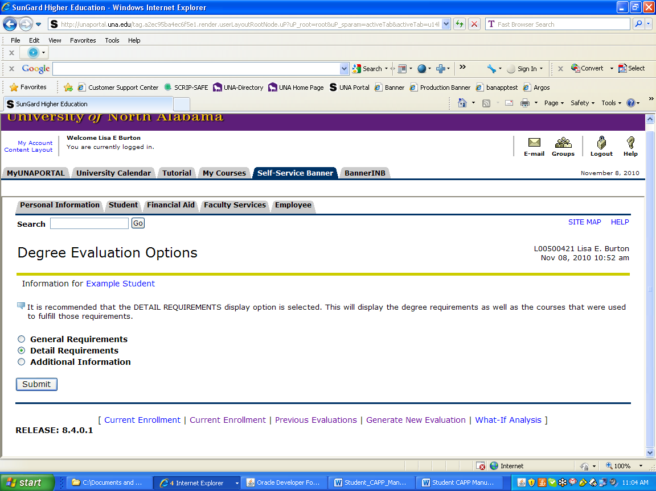

11. Click Submit.
12. The CAPP Degree Evaluation will be displayed. (See page 11 for instructions on How to
Interpret a Degree Evaluation)

Generate a

What-If Analysis

1. Log in to https://unaportal.una.edu
2. Click on Self-Service Banner.
3. Select the Student Tab.
4. Select the Student Records link.

5. Click the link for CAPP Degree Evaluation.
6. Select the current term from the drop down menu

7. Click Submit.

8. Click Generate New Evaluation at the bottom of the page.

9. Select the program requirements by clicking in the radio button next to the curriculum
information.

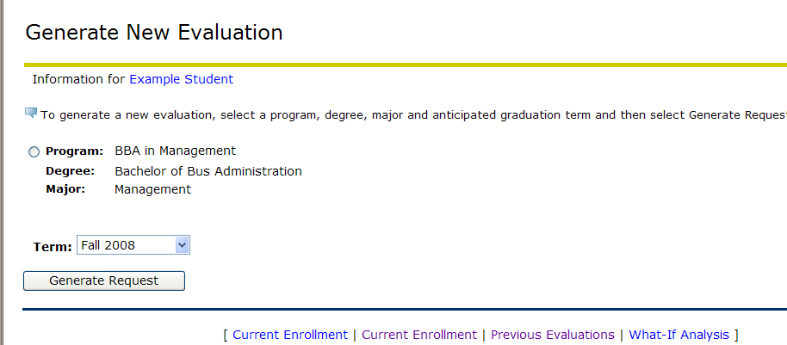

10. Click General Request.

11. Select a CAPP Degree Evaluation display option in order to view the Degree Evaluation.
The options are General Requirements, Detail Requirements or Additional Information.

Note: It is recommended that the Detail Requirements display option is
selected. This will display the degree requirements as well as the courses
that were used to fulfill those requirements.

12. Click Submit.

13. The CAPP Degree Evaluation will be displayed. (See page 11 for instructions
on How to Interpret a Degree Evaluation)

Generate a

What-If Analysis
1. Log in to https://unaportal.una.edu
2. Click on Self-Service Banner.
3. Select the Student Tab.
4. Select the Student Records link.

5. Click the link for CAPP Degree Evaluation.
6. Select the current term from the drop down menu.

7. Click Submit.
8. Click What-If Analysis at the bottom of the page.

9. Select the current term from the drop down menu.

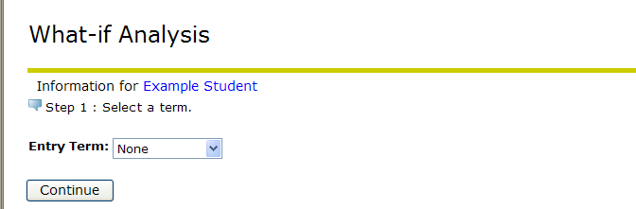

10. Click Continue.

11. Select the program you would like to evaluate.

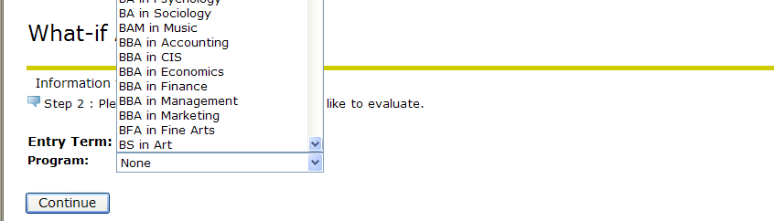

12. Select the major associated with the selected program.

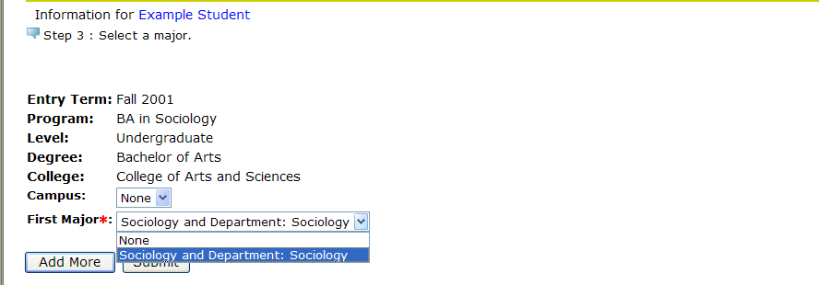

13. Click Submit.
Note: If you would like to select a second major, a minor or a concentration, Click
add more.

14. Verify the program and major selected are correct.

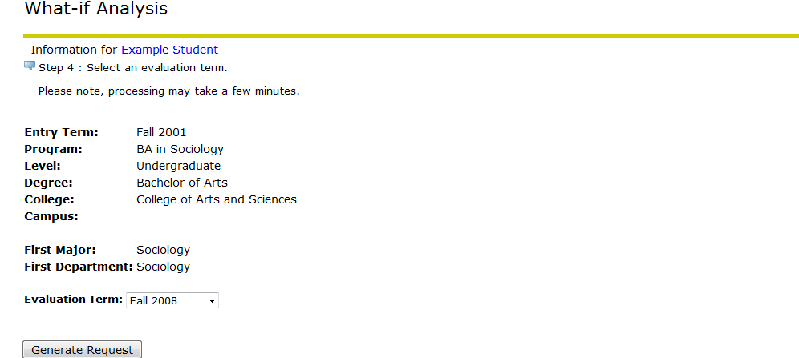

15. Click Generate Request.

16. Select a CAPP Degree Evaluation display option in order to view the Degree Evaluation.
The options are General Requirements, Detail Requirements or Additional Information.

Note: It is recommended that the Detail Requirements display option is selected.
This will display the degree requirements as well as the courses that were
used to fulfill those requirements.

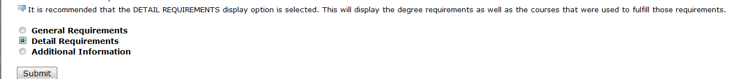

17. Click Submit

18. The CAPP Degree Evaluation will be displayed. (See page 11 for instructions on How
to Interpret a Degree Evaluation)

How to Interpret a

Degree Evaluation

Program Evaluation

The Program Evaluation section appears in both the General and Detail Requirements display options. It displays general information for the evaluation such as Program, Degree, Major etc.

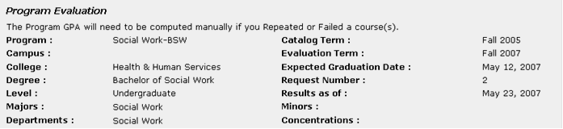
4
3
2
1
- Program: Indicates the degree and major that is evaluated.

- Catalog Term: Indicates the set of General Education requirements that are used to create the evaluation. Catalogs from Fall 2000 – present are available for degree evaluation. Term codes may appear in two formats:

- The term followed by the year (for example, Fall 2007)

- The four-digit year followed by a two-digit code for the term (for example, 200710) (two digit code for the Spring is 20 and Summer is 30).

- Evaluation Term: Indicates the term for which the evaluation is generated.

- Results as of: Indicates the date the evaluation was generated.

14
13
12
11
10

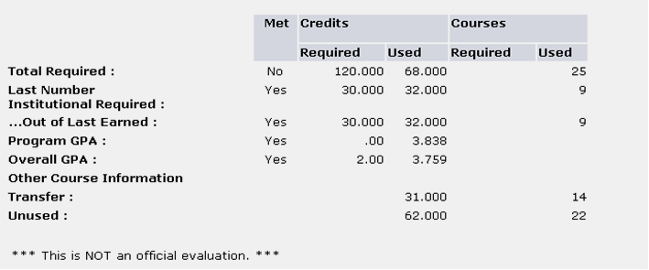
9
8
7
6
5
- Total Required: Indicates the overall number of hours required for the Program.

- Program GPA: Indicates courses that are used for this specific evaluation. If you have repeated or failed any courses, you will need to compute your GPA manually. Some departments are not using this section of the degree evaluation, so you may not have an entry here.

- Overall GPA: This is you cumulative GPA.

- Transfer: Indicates the total number of transfer hours used for this evaluation.

- Unused: Indicates courses that did not meet any of the requirements for this evaluation.

- Met (Yes/No): Indicates whether the requirement has been met.

- Credits (Required): This information is not used in the Program Evaluation, but it may be used for the General and Detail Requirements (pages13 and 15).

- Credits (Used): The actual number of credits used in each category for this evaluation.
used credits include any in-progress courses.

- Courses (Required): This information is not used in the Program Evaluation, but it may
be used for the General and Detail Requirements (pages 13 and 15).

14. Courses (Used): The actual number of courses used in each category for this evaluation.

General Requirements

The General Requirements display option will display a summary of courses used to meet the requirements; however, it will not display the actual degree requirements.
15
16

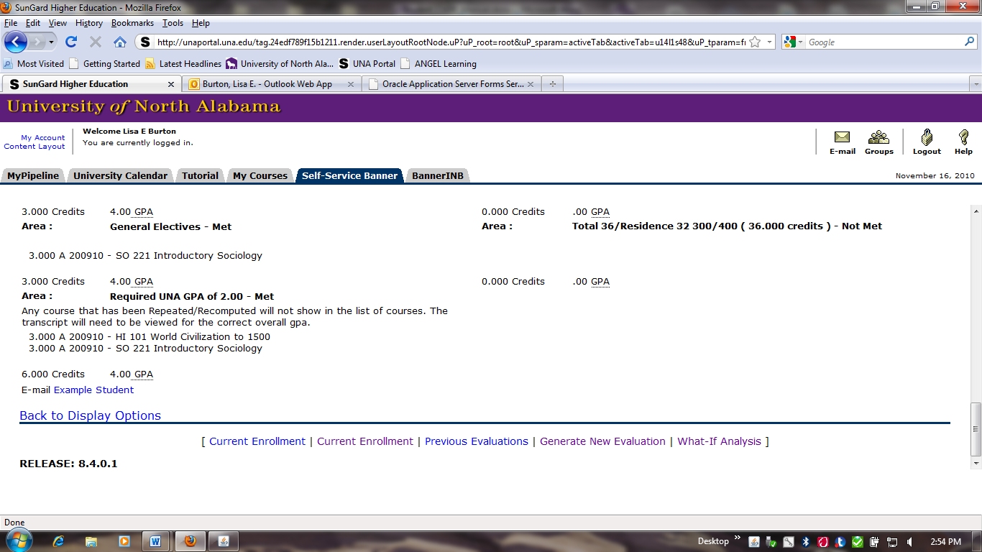
a
c
b
e
d
20
18
19
17

- Area: A set of requirements for the program being evaluated. Areas and groups are
interchangeable for degree evaluation purposes.

- Met/Not Met: Indicates whether the requirement has been met.
Course Information:
- Credits: Number of credits earned for a course.
- Grade: Grade earned for a course. In-progress courses will have an
an asterisk (*) in this column.
- Term: Term in which the course was taken. Term codes may appear in two formats:
- The term followed by the year (for example, Fall 2007)
- The four-digit year followed by a two-digit code for the term (for example, 200710) (the two digit code for the Spring term is 20 and Summer is 30).

- Subject/Course Number: Subject name and course number for a course taken.
- Title: Title of a course taken.

- Area Credits: Indicates the total number of credits used to satisfy the requirements of this area.

- Area GPA: Indicates the GPA for the courses used to satisfy the requirements of this area.

- Email: Clicking on this hyperlink will open up a new email message that will be sent to your academic advisor.

- Area Text: Additional information relating to the requirements, which may include links to other University of departmental websites.

Detail Requirements

The Detail Requirements display option will display a detailed list of the degree requirements as well as the courses from your academic record that were used to meet the requirements.
30
29
31
32
33
37
35
36
34
28
27
26
25
24
23
22
21
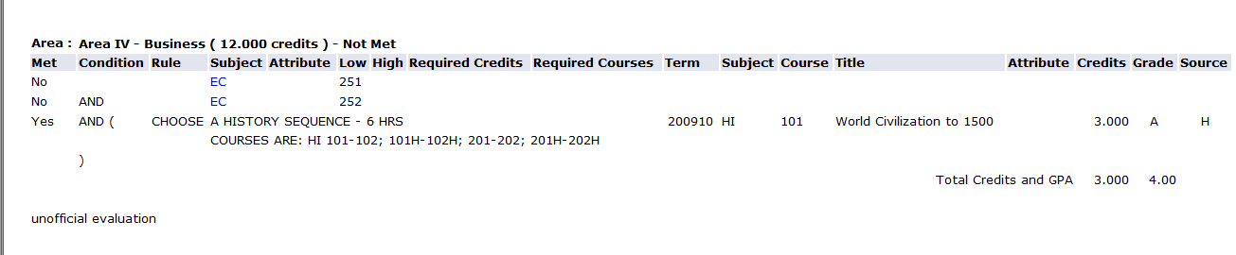

Requirement Information: This section gives detailed information about a set of requirements. This information will appear to the left of the Term section (shown here as left of the red dotted line).

- Met/Not Met (Yes/No): Indicates whether the individual requirement has been met.

- Condition (And/Or): The “and” condition indicates that the requirement must be fulfilled using both of the courses shown. The “or” condition indicates that the requirement must be fulfilled using either of the courses shown.

- Rule: If shown, indicates a condensed or complex requirement.

- Subject: Subject name of a course requirement.

- Attribute: Course attributes identify specific characteristics of courses that can be used in a degree evaluation (e.g., Online MBA or undergraduate online nursing attributes).

- Low: If shown, indicates the lowest course number that will fulfill the requirement. If
a “low” and “high” course number appear, this indicates a range of course numbers that
can be used to fulfill the requirement.

- High: If shown, indicates the highest course number that will fulfill the requirement.
If both a “low” and “high” course number appear, this indicates a range of course numbers
that can be used to fulfill the requirement.

- Required Credits: If shown, indicates how many credits must be taken to fulfill a specific
requirement.

- Required Courses: If shown, indicates how many courses must be taken to fulfill a specific requirement.

Student Information: This section gives detailed information about courses found in your academic record that have been used to fulfill a particular requirement. This information will appear to the right of the Required Courses section (shown above as right of the red dotted line).

- Term: Term in which the course was taken. Term codes may appear in two formats:
- The term followed by the year (for example, Fall 2007)
- The four-digit year followed by a two-digit code for the term (for example, 200810) (the two digit code for the Spring term is 20, Summer term is 30, and the Fall term is 10).

- Met/Not Met (Yes/No): Indicates whether the requirements for a particular area have been met.

- Subject: Subject name for the course taken.

- Course: Course number for the course taken.

- Title: Title of the course taken.

- Attribute: Course attributes identify specific characteristics of courses that can be used in degree evaluation (e.g., Online MBA or undergraduate online nursing attributes).

- Credits: The number of credits earned for a course.

- Grade: Grade earned for a course. In-progress courses will not have a grade listed in this column. A letter “T” preceding the grade indicates that the course was transferred from another institution.

- Source: Indicates where the course was found on the academic record: T (transfer records), H (academic history), or R (registration records).

Additional Information

The Additional Information display option will display courses that did not match a specific degree requirement and courses that could not be used to fulfill a degree requirement.
44
43
42
41
40
39

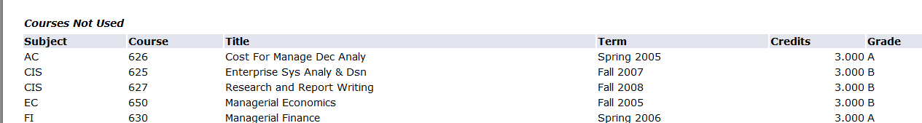

- Subject: Indicates the subject of the course that was taken.

- Course: Indicates the number of the course that was taken.

- Title: Indicates the title of the course that was taken.

- Term: Term in which the course was taken. Term codes may appear in two formats:
- The term followed by the year (for example, Fall 2007)
- The four-digit year followed by a two-digit code for the term (for example, 200710) (the two digit code for the Spring term is 20, Summer term is 30, and the Fall term is 10).

- Credits: Indicates the number of credits earned for the course.

- Grade: The grade earned for the course. In-progress courses will not have a grade listed in this column. A letter “T” preceding the grade indicates that the course was transferred from another institution.

Course Attributes Not Used: The evaluation could not find any requirement that these attributes would fulfill.
51
50
49
48
47
46
45

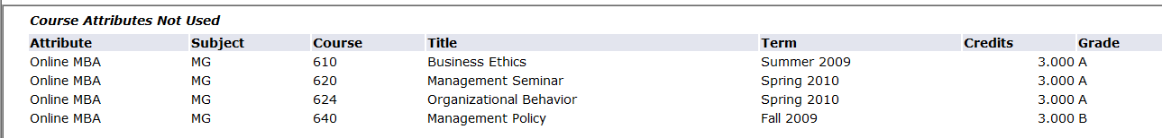

- Attribute: Indicates the course attribute.

- Subject: Indicates the subject of the course that was taken.

- Course: Indicates the number of the course that was taken.

- Title: Indicates the title of the course that was taken.

- Term: Term in which the course was taken. Term codes may appear in two formats:
- The term followed by the year (for example, Fall 2007)
- The four-digit year followed by a two-digit code for the term (for example 200710) (the two digit code for the Spring term is 20, Summer is 30, and the Fall term is 10).

- Credits: Indicates the number of credits earned for the course.

- Grade: Grade earned for the course. In-progress courses will not have a grade listed in this column. A letter “T” preceding the grade indicates that the course was transferred from another institution.

Rejected Courses: Courses in this section match a specific requirement but were rejected for the evaluation. For example, the course may have been repeated or failed or the credit hour/grade did not match the requirement.

55
54
53
52

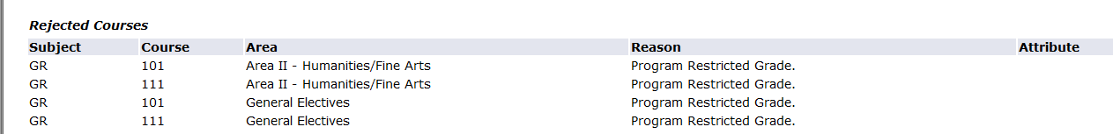

- Subject: Indicates the subject of the course that was taken.

- Course: Indicates the number of the course that was taken.

- Area: Indicates the requirement that the course could meet. Areas and groups are interchangeable for degree evaluation purposes.

- Reason: Indicates why the course was rejected. For example:
- Outside Credits Per Crse Range – indicates that the number of credits earned in the course either exceeded or fell short of the number that would satisfy the requirement.
- Repeated Course – indicates that the course was reported.
- Detail Min Grade Not Met – indicates that the grade earned did not meet the minimum grade that is required to complete the requirement.

