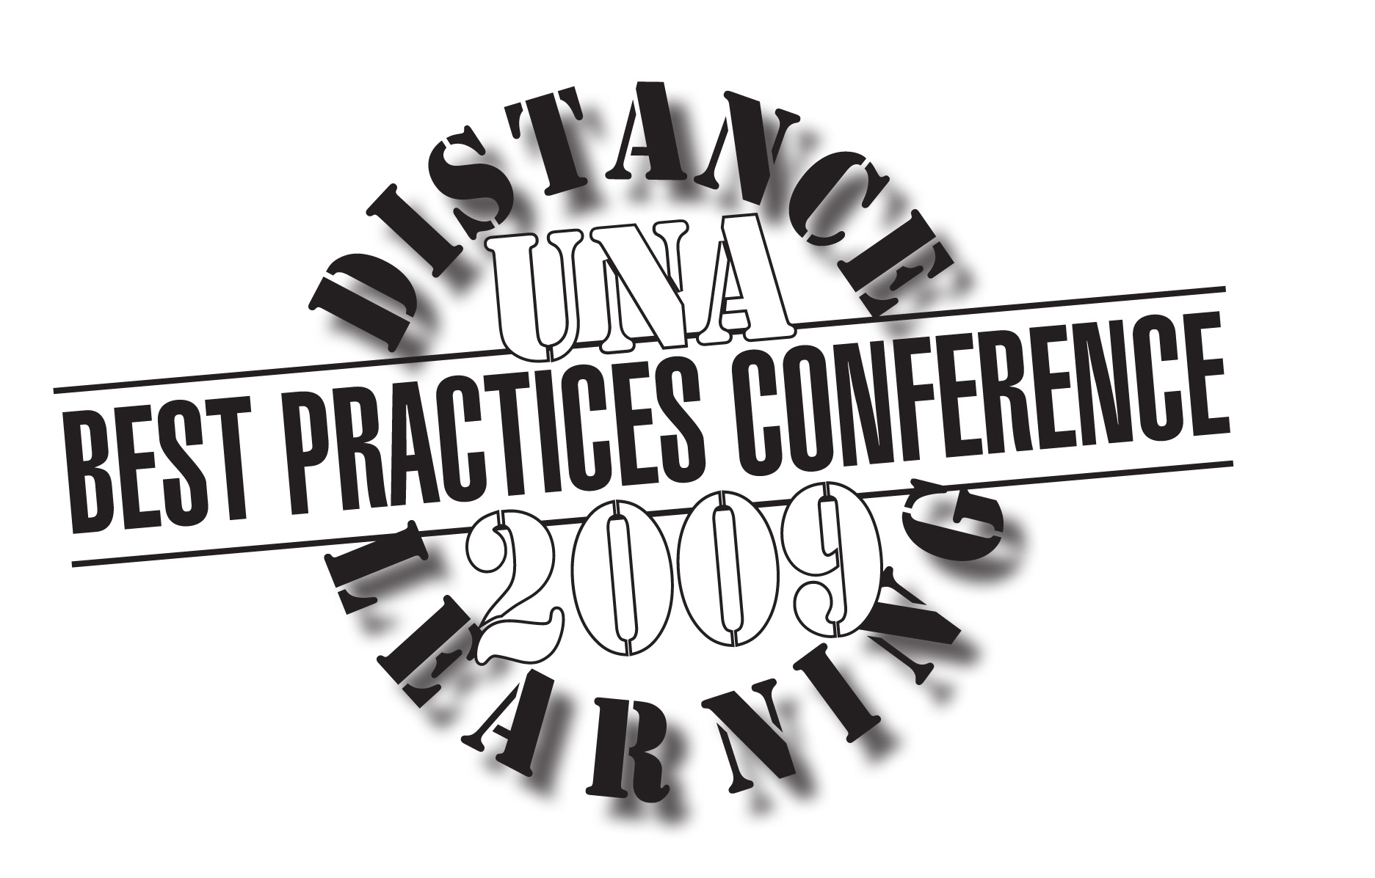
University of North Alabama
Distance Learning Best Practices Conference
Friday, May 8, 2009

Session Schedule

8:30-9:00 a.m. | Welcome  Dr. Maynard  Raburn Room 104
9:00-9:50 a.m. | Don’t Kill the Message  Ms. Thompson  Raburn Room 104 | Survey Says  Dr. Bibbee  Raburn Room 109 | Use of Testing Facility  Dr. Alexander  Raburn Room 206
10:00-10:50 a.m. | Angel Overview  Mr. McGee  Raburn Room 104 |  | Managing Discussion Boards  Drs. Hallock, Gafford  Raburn Room 206
11:00-11:50 a.m. | Using Team Projects  Dr. Balch  Raburn Room 104 | Utilizing Digital Archives  Dr. Bibbee  Raburn Room 109 | Use of Testing Facility  Dr. Alexander  Raburn Room 206
12:00-12 noon | LUNCH | LUNCH | LUNCH
1:00-1:50 p.m. | Pedagogical Approaches/Hybrid Classes  Drs. Gatlin, Clark, Hallock  Raburn Room 104 | Business Simulation Game  Dr. Balch  Raburn Room 109

Please visit the sponsor exhibits in Keller Room 102: Cengage Learning, Wiley, Pearson Education, Elluminate, Tegrity, and Howard Technology Solutions.

Additional Sessions from Vendors (in Raburn Room 110)

10:00 a.m.  Elluminate  (webcast) | 11:00 a.m.  Tegrity  Ms. Pam Smith | 12 noon  Pearson Education  Mr. Tom Nixon

