Student Allocation Funding
Table of Contents

Budget Periods 2
Funding Process 2
Eligibility 3
Appeal Process 3
Areas Available for Funding 4
Travel 5
Event Promotion/Advertising 6
T-shirts and Apparel 6
Prizes 7
Items not funded 7
Purchasing Policies 8
Contracts 8
Coke Products 8
Security Costs 8
Flor-Ala 8
Campus Catering Services 9
Guillot University Center Room Reservations 9
Pre-Approved Vendors for Event Requests 9
Forms and Step by Step Process 10
History and Background 10
Allocation of Fees 11
Purpose 11
Student Government Association 11
SGA Budget Oversight Committee 11
Examples of Budget Documentation 12

Student Leadership Consultants are available in the Student Engagement Office to help with any questions about the funding process. 256-765-4248

Student Allocation Fee Process

Budget Period

Funding Open | For Activities/Travel Occurring
September 1 – November 11 | October 1 - December 31
November 1 – November 25  January 4 – April 21  Januadfa | January 1 - May 31
March 1 – April 21 | June 1 -September 31

Funding Process

- In order to allow the Budget Oversight Committee to make a decision in a timely manner, proposals must be submitted electronically to the SGA Budget Oversight Committee via UNA OrgSync by 4:30 p.m. on Fridays, no later than four Tuesdays in advance of the proposed event/travel date. Due to coordinating funding paperwork within the time-lines set forth by the University Fiscal Affairs Office, there will be no exceptions to this deadline.
- Each Registered Student Organization is limited to only 2 requests per week. Therefore any proposal submitted beyond 2 within a 7 day period will be automatically deleted.
- Upload all supporting documentation. Any screenshots must be compiled in a single Word document. Any request without appropriate documentation will not be funded.
- Proposals are reviewed by the committee on Tuesdays at 3:30 p.m.
- Proposals must be submitted by students utilizing their own UNA OrgSync accounts. Proposals submitted by faculty or staff members will be denied.
- There is a funding limit of $4000 per event request. There is a funding limit of $1500 per travel request.
- Organizations are allowed to have up to two student representatives appear before the SGA Budget Oversight Committee. This is optional.
- Once the committee reviews the proposals, a decision will be made on funding. If an event request is denied, an RSO may not resubmit a request for the same event unless they first meet with a Student Leadership Consultant to review the allocations process. Merely changing the name and date of the event does not constitute a different event.
- Once the proposals are approved by the committee, it will have a “Deferred” status. The student group must meet with Juliette Butler in the Office of Student Engagement within a week of review to ensure paperwork is completed properly. Failure to do this will result in loss of funding for your request without opportunity for appeal.
- The student organization must submit an Evaluation Form and all itemized receipts to Juliette Butler within two weeks of completion of the event/travel. Failure to complete summary and turn in receipts will automatically result in loss of allocated funds and prohibit the RSO from holding an event/travel that is funded by the Student Allocation Fee for six (6) calendar months.
- Student organizations may appeal the committee’s decision electronically via UNA OrgSync to the SGA Budget Oversight Committee within five academic days upon receipt of the denied request .
- Money may not be spent without going through the Office of Student Engagement. The university will not be responsible for any funds spent without approval from the office of student engagement.
- Authorization must be given through the Office of Student Engagement to request contracts from speakers, speakers’ agencies, and entertainment groups. Authorized University officials must sign the contracts; otherwise, the student organizations will be held responsible for all the contract fees.
- Groups may not make any changes to the date of the event/travel without approval from Student Engagement. In emergencies, event dates or travel may be allowed to be rescheduled to a later date, but cannot be moved to an earlier date than what was submitted on the proposal.
- Student organizations may conduct approved fund raising activities at Student Activity Fee supported events providing the purpose of the activity being supported by the fee is not fund raising and the event is free and open to the University community.
- In the event that a RSO is denied funding twice during the same semester due to not adhering to the Student Allocation Manual guidelines, the RSO is required to meet with a Student Leadership Consultant to review the allocations request process before submitting another request.

Eligibility

- All RSOs requesting funding must have the president and treasurer (or another designee) attend a Student Allocations funding workshop in order for their application to be considered complete. In addition, any student RSO representative completing an allocation-funding request must have gone through the training. Faculty advisors cannot request funding for an RSO. No one should complete funding request paperwork unless they attended the Student Allocations funding workshop. The SGA Budget Oversight Committee will host this workshop at the beginning of the fall semester.
Student Leadership Consultants are available in the Student Engagement Office to help with any questions about the funding process. Meetings with Student Leadership Consultants do not replace the workshop attendance requirement.

- Only those organizations recognized by the Office of Student Engagement and in good standing will be eligible for funding. This means that the RSO is updated in UNA OrgSync and all members are listed on the roster. For an organization to maintain University recognition, the group must follow the criteria as outlined in the Student Handbook and RSO Handbook.

A RSO that is newly recognized must wait one semester before being eligible to apply for funding as outlined in the Student Handbook.

- Activities, which are open to all students, may be considered for funding as long as the activity does not discriminate on the basis of race, religion, national origin, gender, age, disability, sexual orientation, or any other basis of discrimination prohibited by law.

- Leadership and conference travel are eligible for funding (up to $1500).

Appeal Process

Recognized Student Organizations may submit an appeal to the Student Government Association based on one or more of the following:

- Procedures were not followed by the SGA Budget Oversight Committee.
- The SGA Budget Oversight Committee deviated from the written policies.

The following are the steps for an appeal process:

- The requestor appeals the SGA Budget Oversight Committee using the Appeals
Form via UNA OrgSync stating the grounds for the appeal. The appeal must be submitted within five academic days from the date of notification of the outcome of the request.
- The SGA Executive Council will determine if the appeal meets any of the previously stated grounds for an appeal and will complete the Appeal Outcome Report Form to document this review.
- If the appeal meets the previously stated grounds, the SGA Executive Council will refer the appeal to SGA Senate to reconsider the proposal and notify the SGA Budget Oversight Committee and the requestor.
- If the appeal is not granted, the original decision goes unchanged and the requestor is to be notified that their appeal was denied.
- The SGA Senate, when reconsidering the proposal, may choose whether or not to award the original allocation per the guidelines in the allocations manual.
- This decision must be communicated to the requestor within five academic days from the date when the appeal decision was made.

The decisions of the SGA Senate are final. Appeals are not granted solely on the basis of disagreement with the decision of the SGA Budget Oversight Committee. Appeals are not granted to RSOs who fail to submit the proper documentation on the original request.

Areas Available for Funding

- Program Support
The University of North Alabama will have some type of campus wide programming needs that contribute to the well-rounded experience for their students. This helps to build a vibrant community. Campus wide programming boards/committees and organizations that program events fall into this category:

  - Lecture/Speaker programs
  - Healthy Living programs
  - Music programs
  - Movie series
  - Diverse Population & Issues (ex. multicultural, LGBT, or gender issues)

2. Equipment
All equipment is to be listed under this category. Organizations from time to time need

upgrades of equipment to support their purposes and activities. While the University has a responsibility to provide the basics, there are other needs that facilitate the opportunities for student involvement and campus-wide programming. The equipment must remain on campus and be available to all recognized student organizations. Equipment funded by the Student Allocation Fee becomes property of the University. All equipment must be
returned to the Student Engagement office one week after the sponsored event or the RSO will lose equipment funding privileges until the full cost of the equipment is paid or until the equipment is returned.

Examples:
- Equipment for the RSO Resource Lab in the Student Engagement Center
- Games
- Speakers
- support/equipment for intramural and open recreation

A list of available resources such as games and craft materials can be found on Orgsync in the files section as well as in the Student Engagement Office. The Budget Oversight Committee reserves the right to deny allocations to purchase equipment or require equipment to be rented on the basis of lack of available storage space.

- Travel
This category speaks specifically to travel for student groups to go off campus for events where Students Activity Fee funds are used to support this travel. Travel is permitted without geographic restriction. Travel is defined as travel expenses for lodging, vehicle rentals, airline tickets, private vehicle transportation and registration fees that the Student Activity Fee is paying toward a given trip. This Travel category does not include travel meals, airline baggage fee, parking fee and bus shuttle to and from the airport. Travel paid to bring speakers and performers to campus does not fall into this category, but can be included as a Travel Expense line item in the Event category. Funding for travel is limited to $1500 maximum per event.

Each RSO is limited to one (1) traveling requests per academic year. This may include 1 conference.

  - All receipts for lodging must be itemized and submitted to the Office of Student Engagement.

  - Gas is reimbursed by itemized receipts only for privately owned vehicles. Documentation for gas for personal vehicles should be submitted in proposal requests. Include map quests and provide a calculation.
Example: 400 miles, 20 gallons of gas, $3.35/gallon, $3.35 x 20 gallons = $67 for gas

  - University vans usage is $0.63 per mile

  - University Buses may be utilized for travel to destinations under 100 miles from campus.
University Buses used to provide a looping route for any student to travel from campus to
a campus-wide event at a local off-campus destination are considered program support, not travel and can be listed as travel expense under the Event category.

Rental is as follows:

Time Frame  (starts 30 minutes before departure) | Included Miles | Base Cost | Rate
12-24 Hours | 50 miles | $100 | $1.22 per mile
8-12 Hours | 40 miles | $85 | $1.22 per mile
4-8 Hours | 30 miles | $75 | $1.22 per mile
0-4 Hours | 10 miles | $22 per hour | $1.22 per mile

In addition there is a charge for the bus driver at @12.00/hour (minimum of 4 hours). With trips 6 hours or more, a meal must be provided for the driver and lodging for overnight stays. Cancellations must be made within 48 hours of usage time. The University buses are 22 and 30 passenger capacity.

- Any bus travel over 100 miles from campus must be charted by an external company.

- If a rental vehicle or personal vehicle is used, all gas receipts must be itemized and turned in to Student Engagement to receive reimbursement.

- Hotel receipts need to be turned in for Out of State and In State Travel otherwise the organization or individual will be held responsible for the payment. Students may not make additional charges for the hotel room. If a student chooses to do so, that individual and/or the organization will be held responsible for the payment of that charge.

- RSOs must put four to a hotel room unless there is a gender divide, or not enough students attending to maximize room space.

- If a student fails to attend a trip that was sponsored by Student Allocation Funding, the student must pay the money back. A hold will be placed on the student account until paid. Otherwise, the RSO will be responsible for paying that money back.

- While traveling as a UNA student with expenses partially or completely funded by the SGA Budget Oversight Committee, you must comply with the policies outlined in the
University’s Student Code of Conduct. If a student is in violation of the University’s Student Code of Conduct, the individual and/or organization will have to repay the money. A hold will be placed on the student’s account until paid. Otherwise, the RSO will be responsible for paying back that money.

- Travel for RSO Retreats will be limited to one retreat per academic year. RSOs may not ask for funding for multiple retreats.

- Event Promotion/Advertising
Every event submission must include a copy of a flyer promoting the event. It must include program/event name, date, time, and location on the flyer. It also must include the statement “Made Possible by the Student Activity Fee”. In addition, the RSO must submit the event information for inclusion in the UNA email digest before the event. Any other promotion must be approved by the office of Student Engagement.

- T-shirts and Apparel
Apparel and swag paraphernalia is not allowed if being bought for an organization to have as an identity and/or to market them. Apparel and swag paraphernalia is allowed if it is associated with an event or program the RSO is doing. Buying t-shirts, cups, pens, etc. for a program/event to give to students who attend the program/event is appropriate. We cannot fund paraphernalia that is being used for recruiting and marketing purposes.

The artwork for the t-shirt design must be attached to the funding request and submitted for review. The SGA Budget Oversight Committee must approve all t-shirt designs.
Companies to consider using:

ADWEAR – adweartex@aol.com, 713-953-9881
Award Excellence – myrba@promoae.com, 954-929-4949. The Coleman Group – 256-718-4000
Goodman Sports – 256-766-5760
North Alabama Screen Print

Websites such as CustomInk cannot be used to order shirts. However, you can use CustomInk to design your shirt.

8. Prizes
Prizes should be related to a program and not exceed over $250 per event. Giveaways, including T-shirts, for an event should not exceed $750. The SGA Budget Oversight Committee will not approve gift certificates or gift cards as a prize.

Items Not Funded

- Political activities defined as activities where votes are solicited or activities directed toward the success or failure of a political party, candidate for office, or partisan political group. RSOs hosting voter drives to encourage students to vote in general, without pushing a particular candidate or group, is acceptable.
- Legislative lobbying efforts or student organization events, supplies, or travel intended to help create or directly influence the outcome of pending legislation.
- UNA faculty, staff, and students of sponsoring organization may not receive any non-contractual personal gain from program or activity.
- Activities that generate unrestricted funds. This means that events that charge a monetary admission fee will not be considered for funding.
- Money may not be used to purchase items for the purpose of fundraising or re-sale.
- Any activity that is illegal.
- Funding will not be provided for grants-in-aid, scholarships, wages, loans, individual membership dues, or other compensation to members or officers of organizations.
- Funding cannot be used for donations or charitable contributions. Non-monetary charitable contributions are acceptable (i.e. clothing drive, canned food drive).
- Retroactive funding will not be eligible to cover prior commitments.
- National association group or individual membership dues.
- Legal services or jail bond funds.
- Any programs involving alcoholic beverages or other drugs.
- Non-student generated programming.
- Library materials
- Travel/events used as recruiting efforts.
- Paraphernalia that is being used for recruiting and marketing purposes.
- Gift certificates or gift cards.
- Any items that need to be ordered or shipped from other countries or require payment of import taxes.
- University courses or organizations whose members are required to register for credit as a condition of membership.
- Parking or parking passes
- Any other items not permitted by University or State policy
- Organizations may not request funds to contract event support services with current members of their organization or the advisor(s).

Purchasing Policies:
Approval of your request does not authorize you to make any purchase. Anything that is purchased “out of pocket” with the approval from the Office of Student Engagement requires documentation and will not be reimbursed for taxes. Anything purchased without the written approval from the Office of Student Engagement will not be reimbursed. You must obtain approval from Student Engagement at least 3 weeks prior to the event. Any purchases that are made online need to be coordinated with the Office of Student Engagement. We discourage any group/individual from paying for anything out of pocket.

Contracts:
Contracts to vendors, entertainers etc. need to be initiated at least 4 weeks in advance of the event. Contracts are to be coordinated with the Office of Student Engagement in order to have it processed in a timely manner.

Coke Products:
The University has a contract with Coca-Cola. If groups are planning to buy Sodas, the drinks have to be Coke Products.

Security Costs:
Charges for University police coverage for events are as follows:
Officers - $25.00 per hour, guarantee of 4 hours starting 30 minutes before the event. Request needs to be made to Gloria Michaels, UNA Police Department, Ext 4826, at least one week in advance before the event.

The Flor-Ala:
Materials, artwork etc. for publishing in The Flor-Ala campus newspaper, must be submitted to the Student Media office a week before the publishing date. For rates, polices and due dates, please contact the Office of Student Media at
256.765.4427.

Chartwellls:
All food from Chartwells requires a Purchase Order at least 2 weeks before the event. Any event in the GUC or Towers Cafeteria that requires food/refreshments needs to be coordinated with Chartwells. No outside catering/food will be allowed in the GUC or Towers Cafeteria without Chartwell’s permission. Chartwells may be contacted at una.catertrax.com or at 256.765.5662.

Guilliot University Center
Scheduling of rooms in the GUC, the Performance Center, the Atrium, the Memorial Amphitheatre, and Stone Lodge, needs to be done through the department
of University Events in Room 202, GUC. Scheduling should be done well in advance depending on the availability of the facility. University Events may be contacted at 256.765.4658. For Flowers Hall, contact Athletics at 256.765.5466. For Kilby Gym, contact 256.765.4303. Do not use glitter in any facilities for your events.

PRE-APPROVED VENDORS FOR EVENT REQUESTS
If you choose to request funding for an event from a vendor not included on this list, you must complete and submit a Vendor Quote form (included in this book)and at www.una.orgsync.com.
Chartwells

Forms and Step by Step Process

Step 1: Funding Request Form
Student groups will be required to complete a Funding Request Form when they submit the budget. RSOs will complete this process through UNA OrgSync Treasury. It is due by 4:30 p.m. on Fridays with at least four committee meetings prior to the event, travel, etc.

In UNA OrgSync Treasury, RSOs will be able to complete the form, submit budget request, and upload all supporting documentation. Documents that are screen shots should all be pasted in a single Word document before uploading it.

A “How To” video can be viewed at - www.una.orgsync.com

Step 2: Meet with Student Engagement
Once your request has been reviewed, it will either be “Denied” or “Deferred” with a message explaining the status. If your request is deferred, it means that it will be Approved once you setup a meeting with Juliette Butler in the Office of Student Engagement. You must contact Mrs. Butler within 7 days of the committee’s review of your request to setup a meeting. If you fail to contact Mrs. Butler within 7 days, your requests will be denied and cannot be appealed.

Step 3: Evaluation Form
Evaluation forms are due within two weeks upon completion of the event, trip, or receipt of equipment. There are three types of evaluation forms depending on the type of request that was submitted. Failure to turn in the evaluation forms will lose funding for one academic year. There will be no reminders to submit the forms.
The forms are available in Forms at the UNA OrgSync page: www.una.orgsync.com.

Step 4: Appeal Form
Should a RSO be denied funding for a request, there is an appeal form that may be submitted. The appeal must be submitted to the SGA Budget Oversight Committee via UNA OrgSync within five academic days from the date of notification of the outcome of the request. Student groups may obtain the Appeal Form from by going to the Forms in UNA OrgSync at: www.una.orgsync.com.

Additional Information

History and Background
The University Board of Trustees, with the support of the Student Government Association, approved in June 2005 and again in June 2006 an increase in the Student Activity Fee to $10 for
fall 2006 semester and to $15 for the spring 2007 semester. The fee increased in increments of $5 per semester until it reached a cap of $25 in Spring 2008 semester. The Student Allocation
funding process began in fall of 2007.
The University Board of Trustees, with the support of the Student Government Association, approved in June 2012 that the student activity fee be increased to $27 per semester to allocate
$2 per student to the Game Room.

The University Board of Trustees, with the support of the Student Government Association, approved in June 2014 that the student activity fee be increased again and in June 2015 redesigned the fee structure so that students enrolled in Summer courses would not be charged a fee. The new structure is outlined below:

Fall 2014 $35 per student
Spring 2015 $40 per student
Fall 2015 $45 per student
Spring 2016 $50 per student
Fall 2016 $56 per student

Allocation of Fees
The money generated from the student activity fee will be allocated as follows:

- 44% allocated to the University Program Council
- 36% allocated to the Student Allocation Committee
- 10% will go to Leadership and Volunteerism
- 3% will be allocated to Miss UNA
- 7% will be allocated to the Game Room

The SGA Budget Oversight Committee will meet annually to re-evaluate the division of funding. Funding begins October 1 of each year to coincide with the University’s fiscal year.

Purpose
The University understands that organizations and their activities contribute to the educational, cultural, social, and professional development of the University of North Alabama. The Student Allocations funding process was created by SGA to respond to the needs of the recognized student organizations and enable these groups to develop programming based on the educational mission of the University as outlined in the University Catalog and Student Handbook.

Student Government Association
The Student Government Association Senate will review policies, procedures, and end of the year budget reports to ensure that the student activity funding is being used effectively and efficiently for student programming and development as aligned with the mission of the University. SGA Executive Council will also review appeals and determine if an appeal is warranted. If an appeal is granted, the SGA Senate will make a decision on the funding.

SGA Budget Oversight Committee
The SGA Senate Budget Oversight Committee is made up four senators. In addition, a faculty member serves on the review committee. The SGA Budget Oversight Committee will review and
approve funding proposals that are submitted through UNA OrgSync.

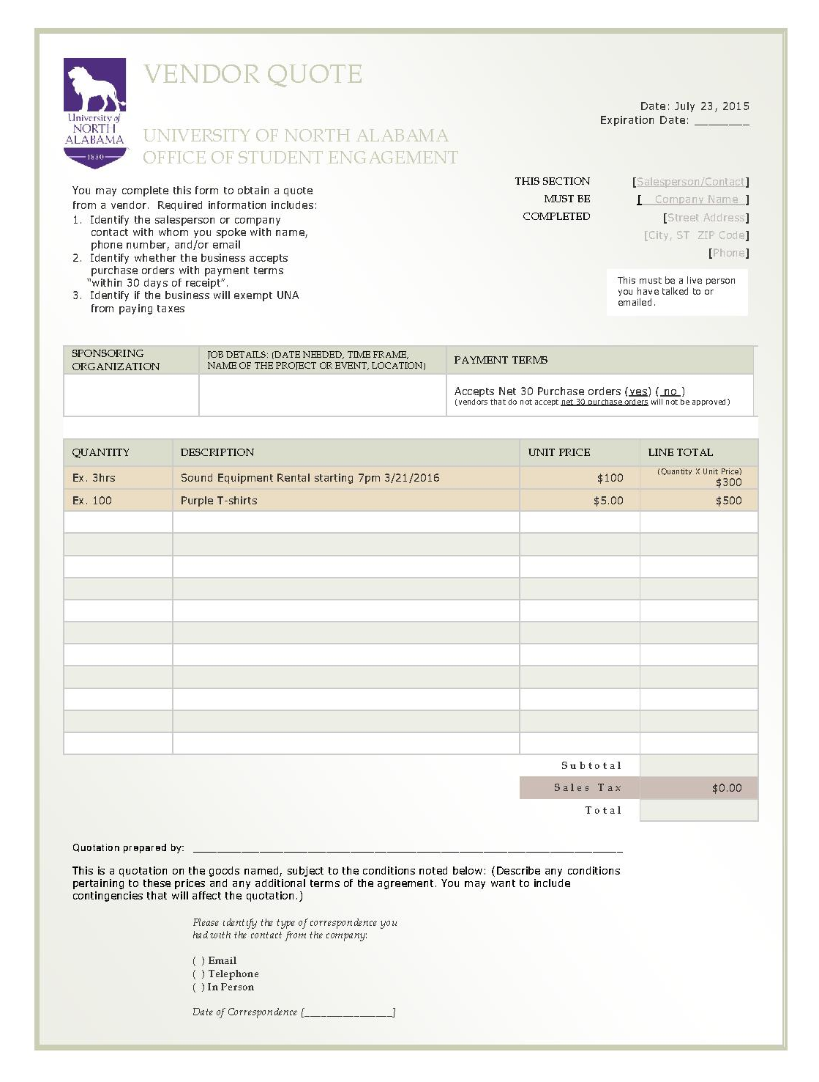
EXAMPLE OF BUDGET DOCUMENTATION

EXAMPLE OF BUDGET DOCUMENTATION

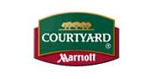 Courtyard Louisville Airport 819 Phillips Lane,
Louisville, Kentucky 40209 USA Phone: 1-502-368-5678 Fax: 1-502-368-5685

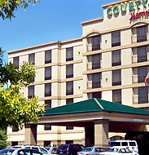

- Confirmation Number: 83129490
- Your hotel: Courtyard Louisville Airport
- Check-in: Friday, March 12, 2010 (03:00 PM)
- Check-out: Sunday, March 14, 2010 (12:00 PM)
- Room type: Guest room, 2 Queen
- Number of rooms: 1
- Guests per room: 1
- Guest name: MARY JANE
- Reservation confirmed: Friday, August 7, 2009 (14:56:00 GMT)
- Guarantee method: Credit card guarantee, Visa
Summary of Room Charges | Cost per night per room (USD)
Friday, March 12, 2010 - Sunday, March 14, 2010 ( 2 nights ) | 114.00
Weekend rate
Estimated government taxes and fees | 17.11
Total for stay (for all rooms) | 262.22
- Complimentary on-site parking
- Changes in taxes or fees implemented after booking will affect the total room price.
You may modify or cancel your reservation online (see details below), or call 1-800-321-2211 in the US and Canada. Elsewhere, call our worldwide telephone numbers.
Contact us if you have questions about your reservation.

EXAMPLE OF BUDGET DOCUMENTATION

Thank you for choosing Delta. We encourage you to review this information before your trip. If you need to contact Delta or check on your flight information, go to delta.com, call 800-221-1212 or call the number on the back of your SkyMiles® card.
Now, managing your travel plans just got easier. You can exchange, reissue and refund electronic tickets at delta.com. Take control and make changes to your itineraries at delta.com/itineraries.

Flight Information
DELTA CONFIRMATION #: D981HV
TICKET #: 00623107706480
Bkng Meals/ Seat/
Day Date Flight Status Class City Time Other Cabin
--- ----- --------------- ------ ----- ---------------- ------ ------ -------
Thu 23JUL DELTA 6350* OK K LV HUNTSVIL/DEC 545A 9C
ATUR COACH
AR ATLANTA 745A
*Operated by COMAIR

Thu 23JUL DELTA 1001 OK K LV ATLANTA 824A V 17C
AR SAN ANTONIO 952A COACH

Passenger Information
MARY JANE
SkyMiles Number: *******665
Billing Details
Receipt Information
Fare Details: HSV DL X/ATL DL SAT169.30KA21A0NQ USD169.30END ZP HSVATL XF HSV
4.5ATL4.5

Fare: 169.30 USD
Tax: 33.90 TX
Total: 203.20 USD

. Detailed Tax Information
Total Tax: 33.90 USD
XF 9.00 ZP 7.20 AY 5.00 US 12.70

EXAMPLE OF BUDGET DOCUMENTATION

 INVOICE
www.crescentmoontalent.com/

DATE: 4/30/08

BILL TO: FOR: Delicious
University of N. Alabama LOCATION: Performance Center, GUC
615 North Pine St.
Florence, AL 35632 SHOW DATE: 4/24/08

DESCRIPTION | AMOUNT
  UPC Concert
  $2000.00
BALANCE DUE | $2000.00

BALANCE DUE UPON RECEIPT!
Please make check payable to:
CRESCENT MOON TALENT, INC.
20 MUSIC SQUARE WEST
NASHVILLE, TN 37203

THANK YOU!
If you have any questions concerning this invoice, please contact:
CAROL HALL
Office Manager
carol@cmtalent.com
615-254-7553 ext. 207

EXAMPLE OF BUDGET DOCUMENTATION
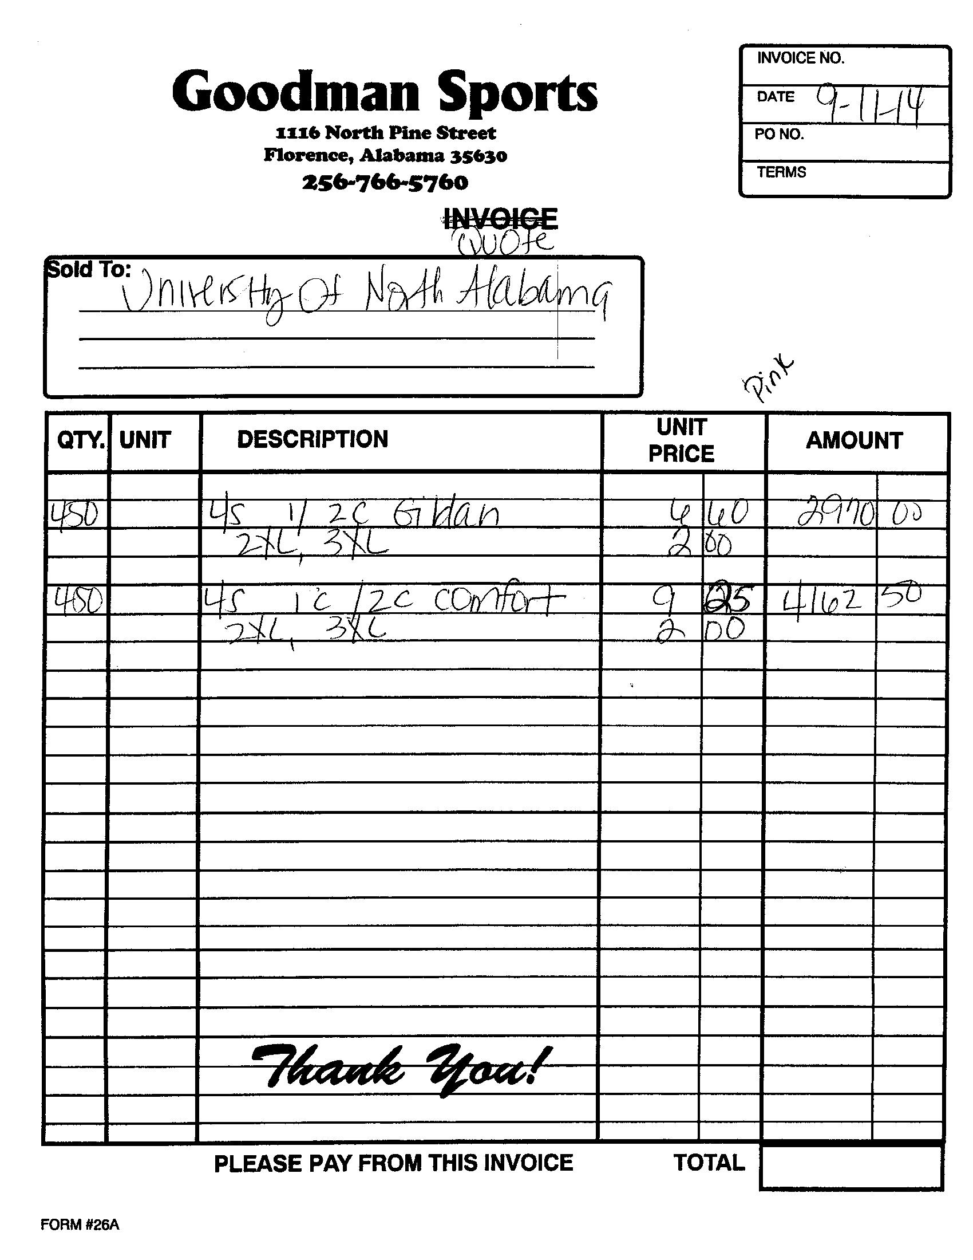

EXAMPLE OF BUDGET DOCUMENTATION

